Bayview – Rowland Reserve
Seaview Pde., Collaroy,
Northern Beaches, NSW

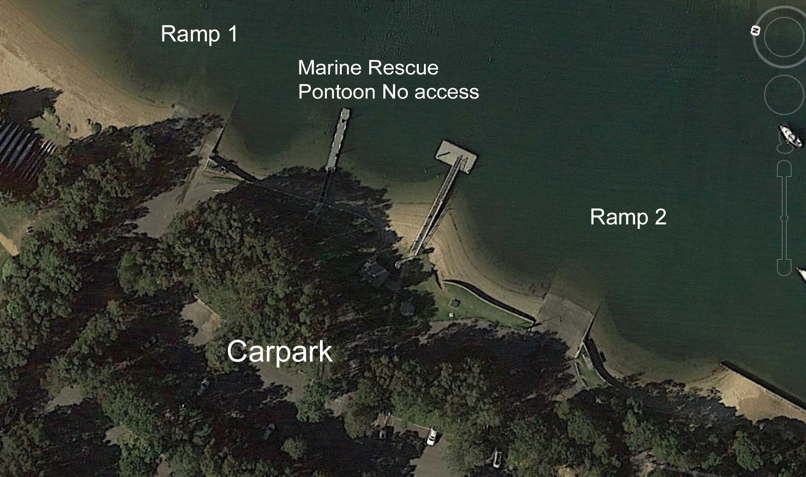

GPS 33°44'19"S 151°18'27"E

There are two separate boat ramps at this location.

Lanes 2 Surface Concrete Condition Poor
Wharves One floating pontoon (refer to notes)
Tides Works in all tides

Parking
There is ample parking at this location however it is not exclusively for boats and trailers. It also a public reserve which has a safe beach for children so at busy times parking is limited.

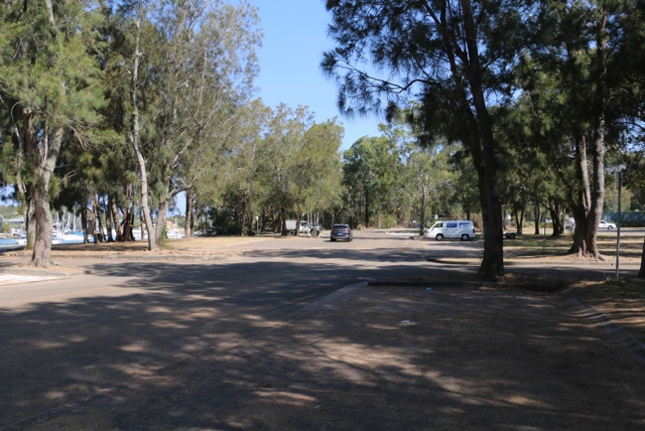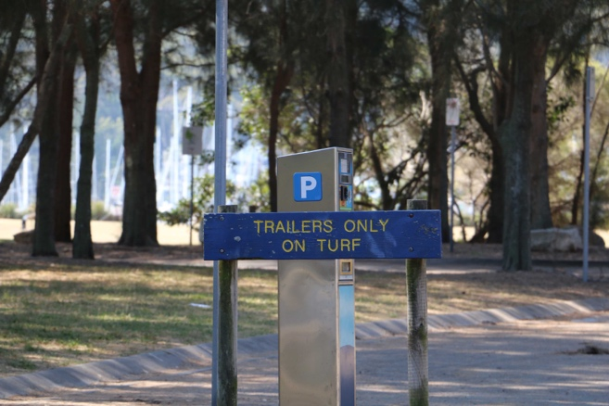

Cost 2 different rates:

May 1st to September 30 - $5 per hour or $22 per day
October 1st to April 30 - $6 per hour or $25 per day

Facilities Fish cleaning table, lights, picnic tables

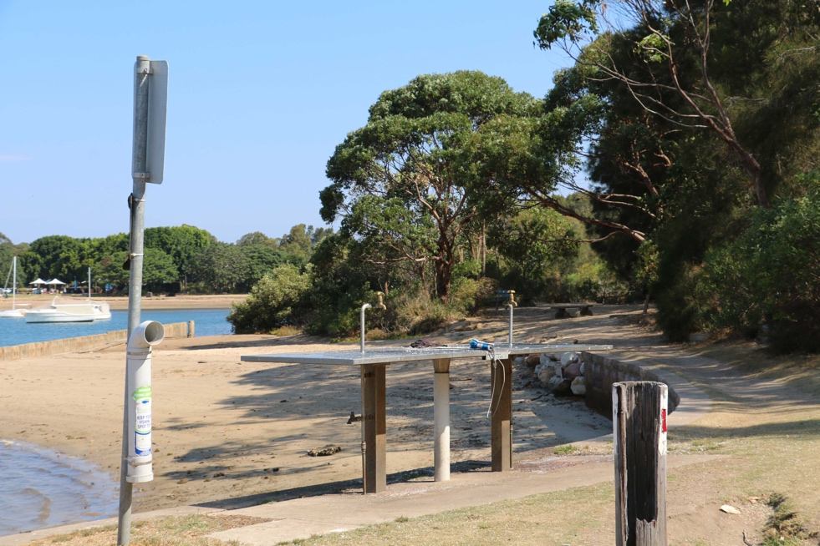

Fuel
Mobil, 24 Barrenjoey Rd., Mona Vale, 2103 Ph. (02) 9997 5934
BP, Cnr. Barrenjoey and Darley Rd., Mona Vale, 2103 Ph (02) 9999 4633

Services
This ramp is approximately 1.5 km from the Mona Vale shopping centre which is well equipped with a Coles Supermarket, Dan Murphys liquor outlet and several cafes, restaurants.

Fishing Tackle & Bait (nearest)
Narrabeen Bait and Tackle, 1469 Pittwater Rd., North Narrabeen Ph. (02) 9970 6204
Fishing Station, 50 Darley St, Mona Vale Ph. (02) 8094 9197
Sneaky Fisho, 533 Pittwater Rd, Brookvale Ph. (02) 9949 9488

Local Knowledge

This is the most popular ramp for people living on the northern beaches to get access to the Pittwater. It is very protected both from wind and swell. There are actually two ramps at this location and plenty of parking so access to the water is good.

There is however only one pontoon available for tying up to and it is very small. There is another pontoon between the two ramps but there is no public access to this pontoon as it is reserved for Marine Rescue use only.

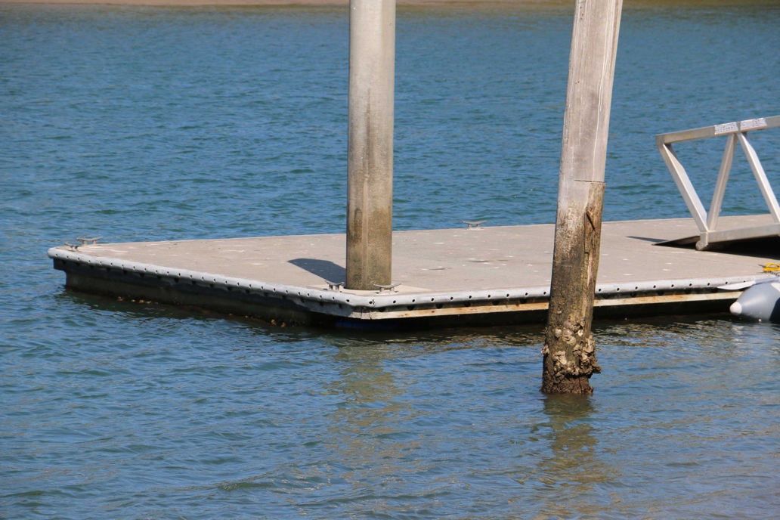

Whilst there is limited pontoon access available to people launching and retrieving boats, there is plenty of sandy beach to pull a boat onto to collect or drop off passengers.

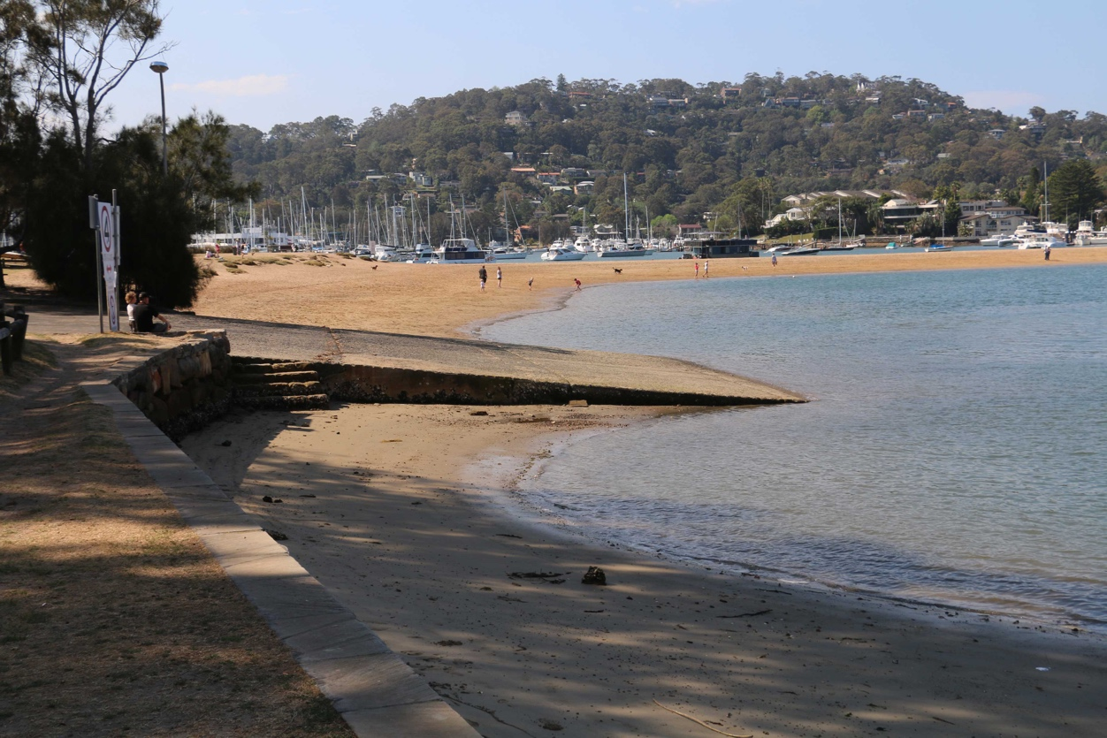

Boat Ramp Etiquette

To avoid ramp rage, please try and remember these basic boat ramp rules when launching and retrieving;

Prepare your boat before you reverse onto the ramp – ie bungs in, straps off and equipment in the boat

Beware of slippery ramps, particularly when tide is low – if you have a four wheel drive, use it. Every year, many cars are ruined when they are dragged by their boats into the water during launching or retrieval.

Make sure you have plenty of fuel and your batteries are working – running out of fuel or dead batteries are the two most common reasons for boaties needing rescue every year.

