Bicheno
The Esplanade, Bicheno, Tasmania
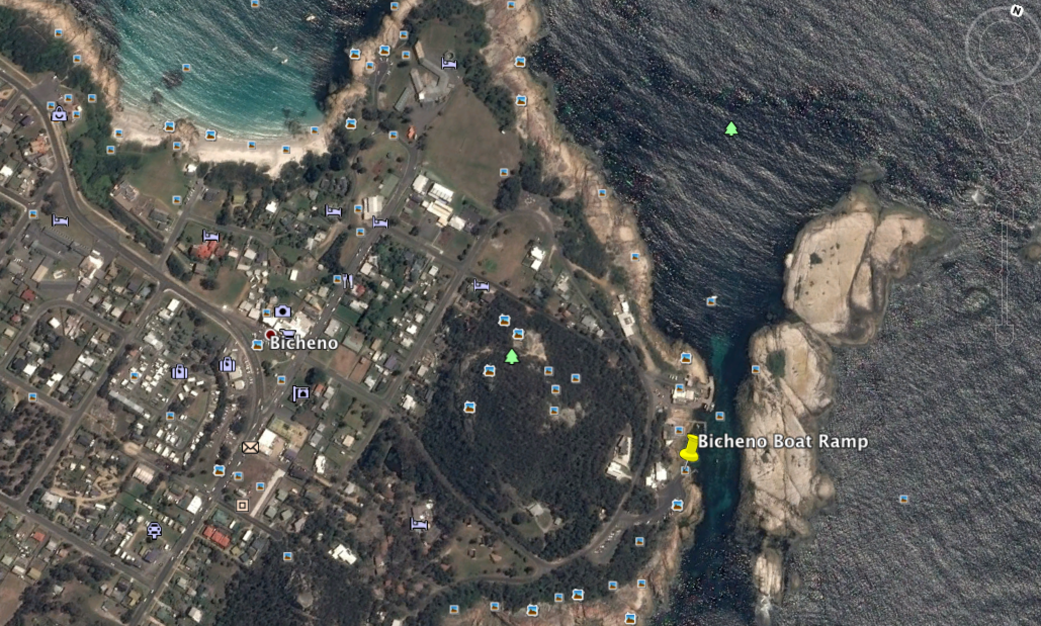

GPS 41°52'28.11"S 148°18'39.87"E
Lanes 2 Surface Concrete Condition Good
Wharves 2 Fixed wharves, timber bollards
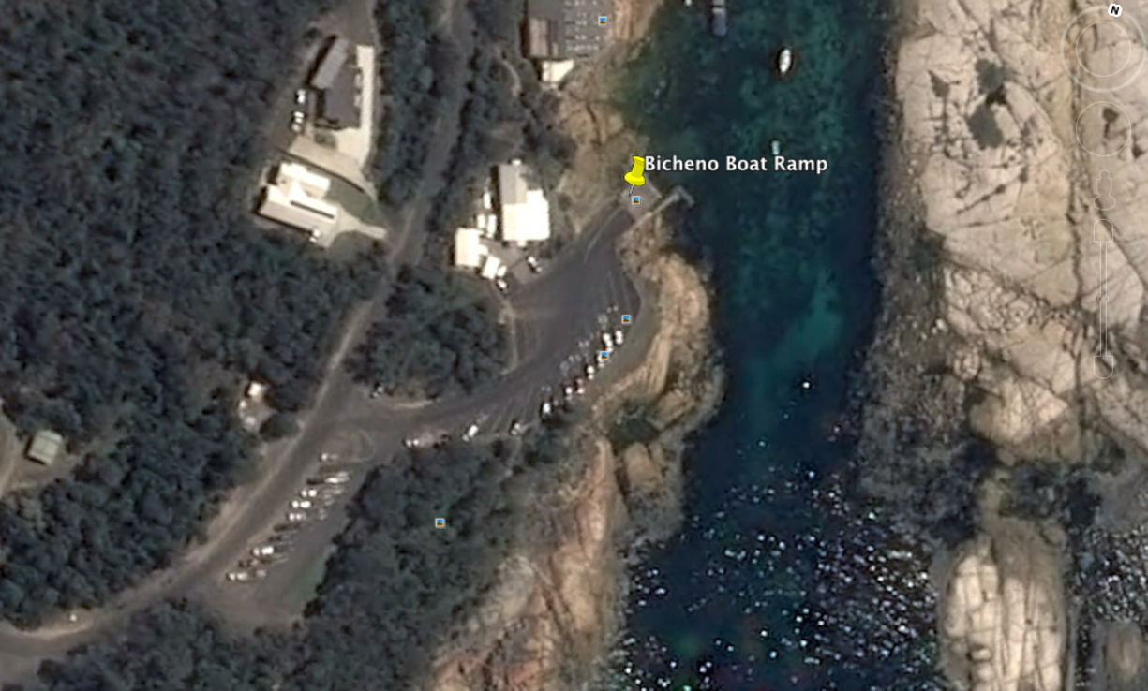
Tides Works in all tides

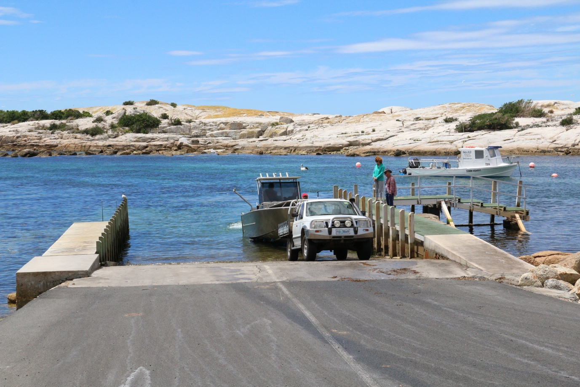

Parking Ample. Additional parking nearby when main car park is full.

Cost Nil

Facilities Toilets, Lighting

Fuel
United Petroleum, 28 Tasman Hwy., Bicheno
BP, Foster St., Bicheno

Services
Approx 600 metres to the town shopping centre. Cafes, Restaurant, Supermarket, etc.
Fishing Tackle & Bait
St. Helens or Scaramander

Local Knowledge

This is a well protected ocean launching ramp. The ramp area is situated between mainland Tasmania and a small rocky island named Government Island. Access to the ocean is via either end of the island as shown on the photos.

There is a nearby fish and chip shop and commercial boat yard whilst the town of Bicheno is approximately 600 metres away.

Do not be confused by the old boat ramp which is on the northern side of Peggy’s Point, north of the current boat ramp. This old boat ramp is good for dinghy’s only and is used by commercial fishing to get to and from their boats moored in the harbour.

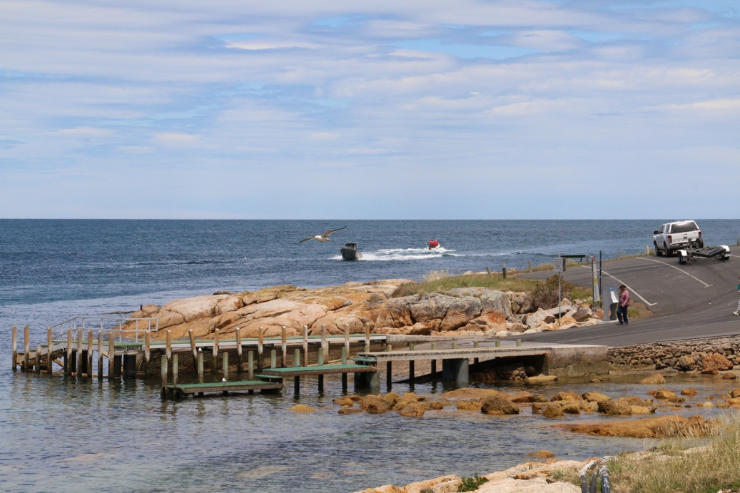

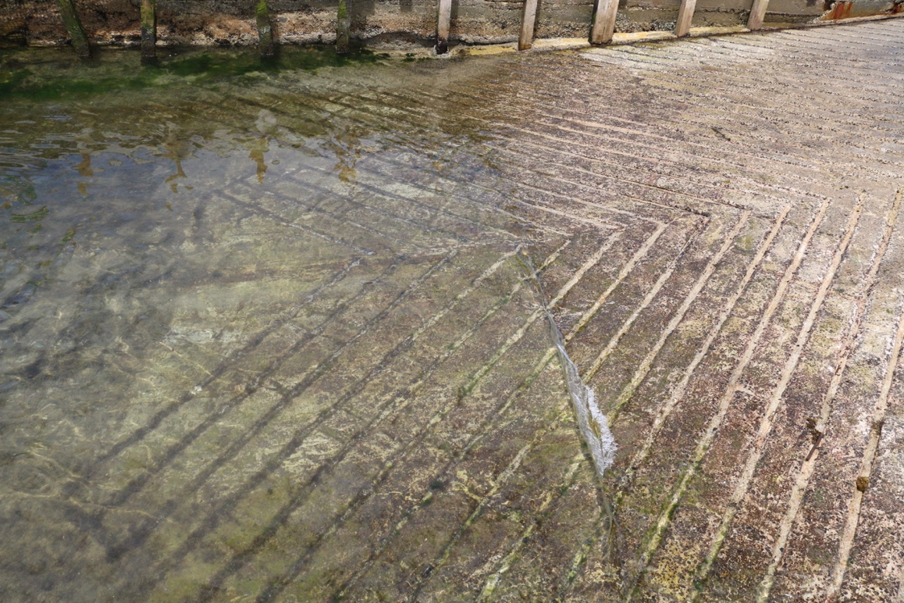

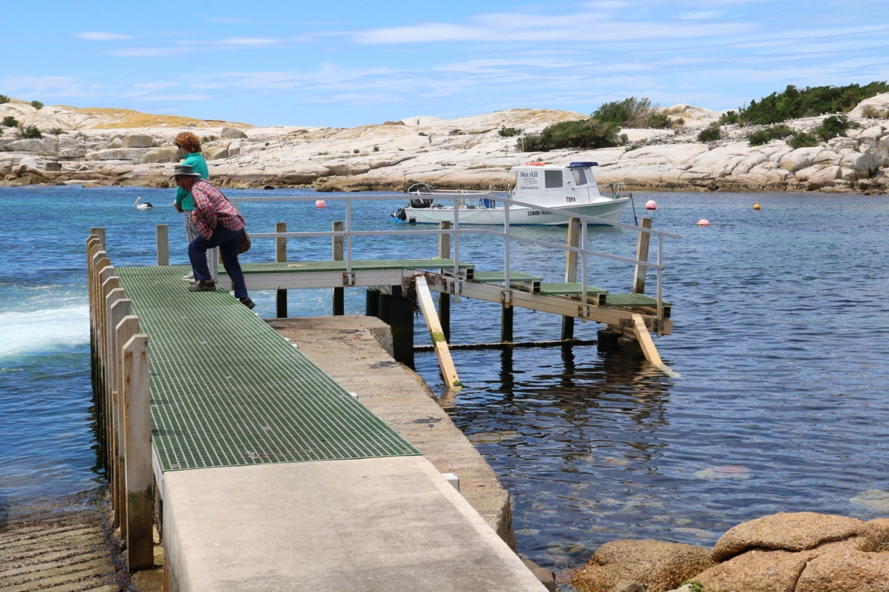

Boat Ramp Etiquette

To avoid ramp rage, please try and remember these basic boat ramp rules when launching and retrieving:-

Prepare your boat before you reverse onto the ramp – ie bungs in, straps off and equipment in the boat

Beware of slippery ramps, particularly when tide is low – if you have a four wheel drive, use it. Every year, cars are ruined when they are dragged by their boats into the water during launching or retrieval.

Make sure you have plenty of fuel and your batteries are working – running out of fuel or dead batteries are the two most common reasons for boaters needing rescue every year.

If you are going offshore and there is a facility such as Marine or Sea Rescue, Coastguard, or VMR which operates a log on and log off service, use it.

