Bridport
Pier Point Bentley St., Bridport, Tasmania

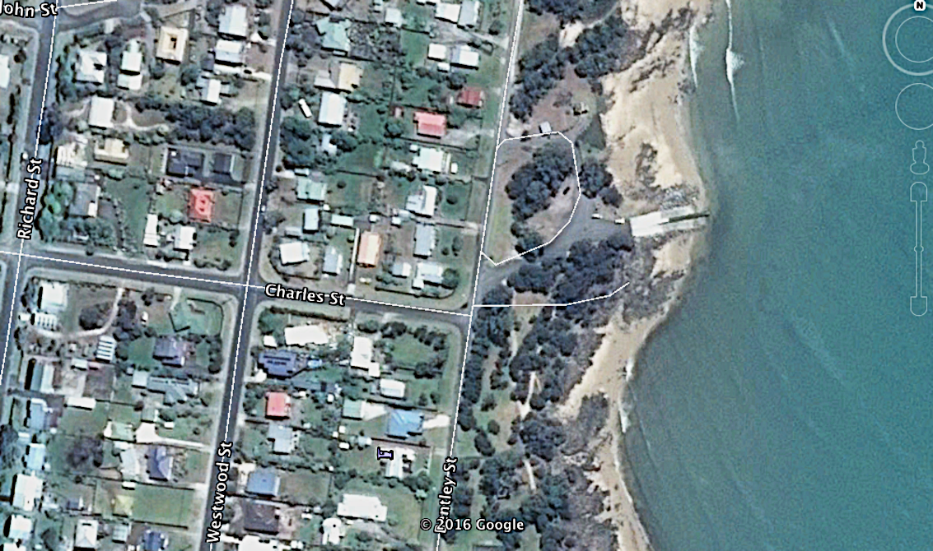

GPS 40°59'26.57"S 147°23'24.45"E
Lanes 2 Surface Concrete Condition Good
Wharves 1 Fixed wharf
Tides Works in all tides

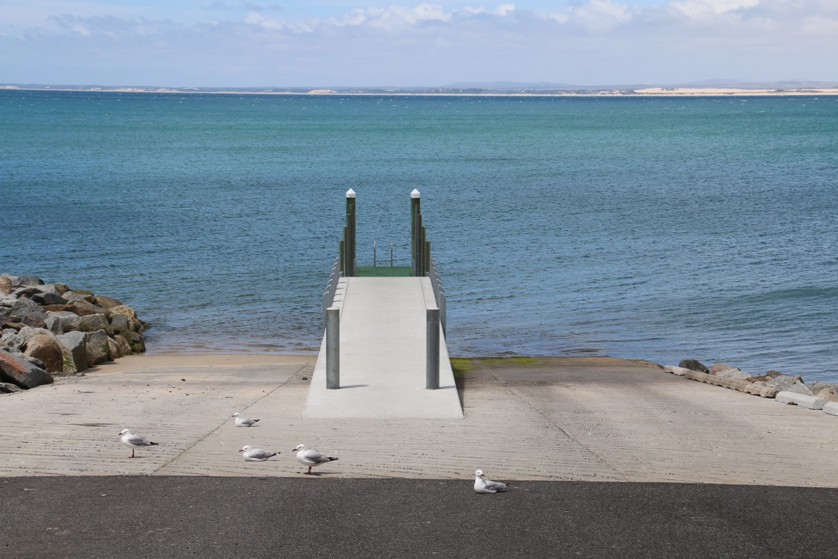
Parking Limited in small car park however parking on the nearby roadway is possible.

Cost Nil

Facilities Toilets, Lighting, good fenders on jetty

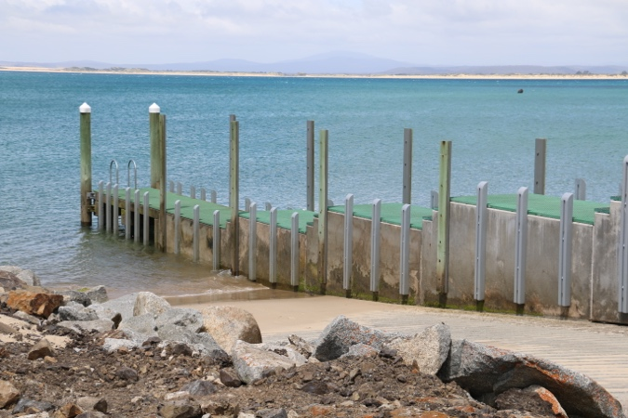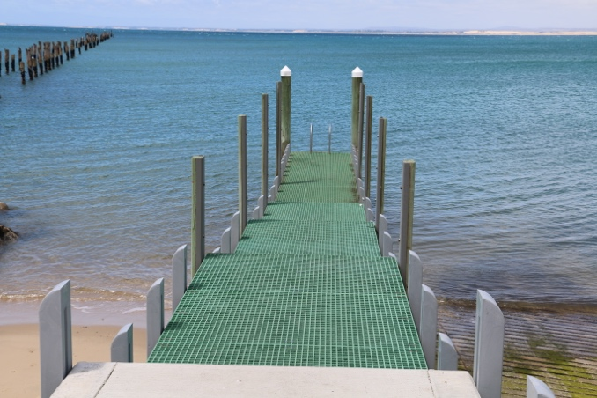

Fuel
Caltex, 71 Main St., Bridport (03) 6356 1215
Services
The main shopping strip is only 1.2 km from the boat ramp and has a small supermarket, several cafes and a hotel. The boat ramp is beside a very nice caravan park that runs along the beach from the boat ramp almost as far as the estuary. This caravan park has plenty of grass, shade and good facilities. They will also let you have open fires. https://bridportcaravanpark.com.au

Fishing Tackle & Bait
There is a small amount of fishing tackle available in the local supermarket.

Local Knowledge

This is a new ramp and consequently it is in good condition although the facilities are limited. It is called the Pier Point Boat Ramp because it is located beside what is known as the Granite Point pier which was built in 1916 and which was the end point of the 28 km Forester to Bridport Tramway which brought sawn timber to the port for shipment to Melbourne, during the period 1913-25. This pier was partially burned by arsonists in 1938 and finished off by another fire in 1941.

Despite the good condition of this ramp it is prone to being affected by ocean swell which pushes directly onto the ramp in a northerly and big westerly swells can also wrap around the point into Anderson Bay. For this reason, some locals prefer to use the estuary boat ramp which is completely sheltered.

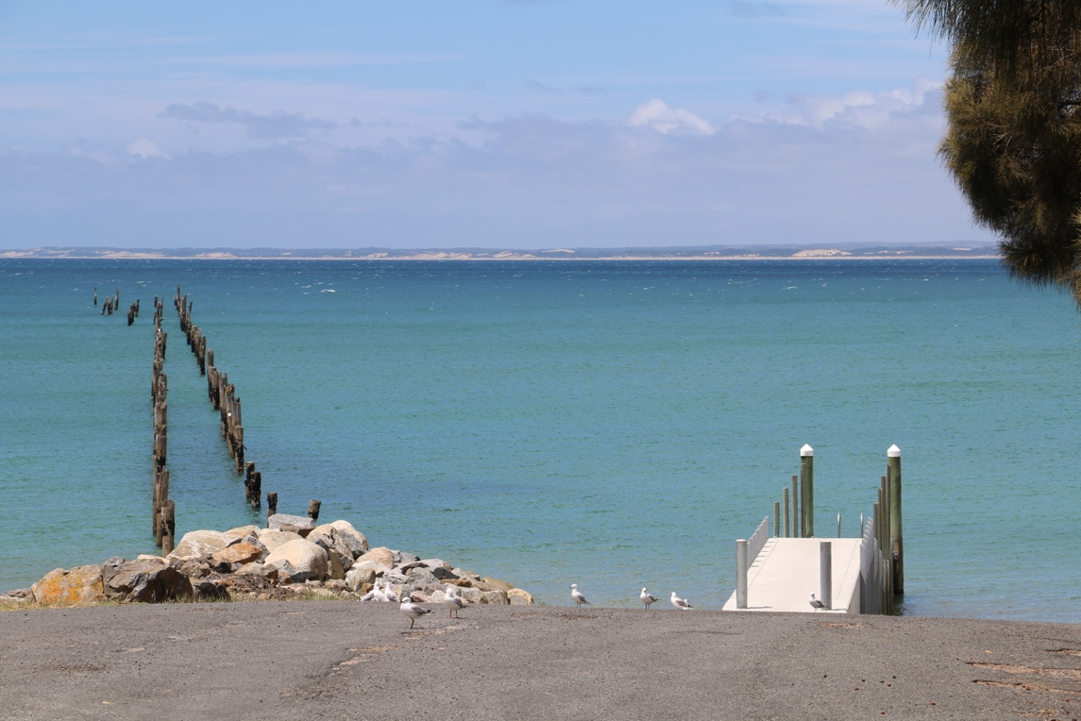
Boat Ramp Etiquette

To avoid ramp rage, please try and remember these basic boat ramp rules when launching and retrieving:-

Prepare your boat before you reverse onto the ramp – ie bungs in, straps off and equipment in the boat

Beware of slippery ramps, particularly when tide is low – if you have a four wheel drive, use it. Every year, cars are ruined when they are dragged by their boats into the water during launching or retrieval.

Make sure you have plenty of fuel and your batteries are working – running out of fuel or dead batteries are the two most common reasons for boaters needing rescue every year.

If you are going offshore and there is a facility such as Marine or Sea Rescue, Coastguard, or VMR which operates a log on and log off service, use it.

