Bridport
Bridport Estuary, Tasmania

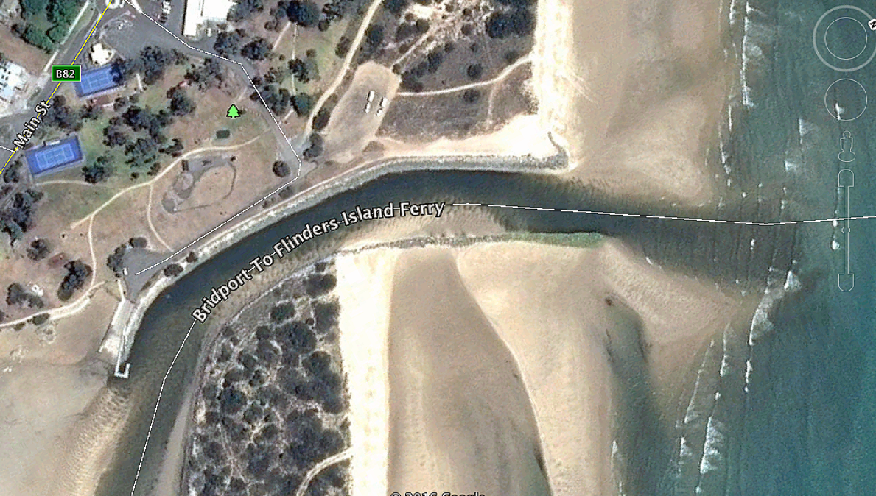

GPS 41° 0'13.58"S 147°23'47.17"E
Lanes 2 Surface Concrete Condition Good
Wharves 1 Floating pontoon jetty
Tides Works in all tides

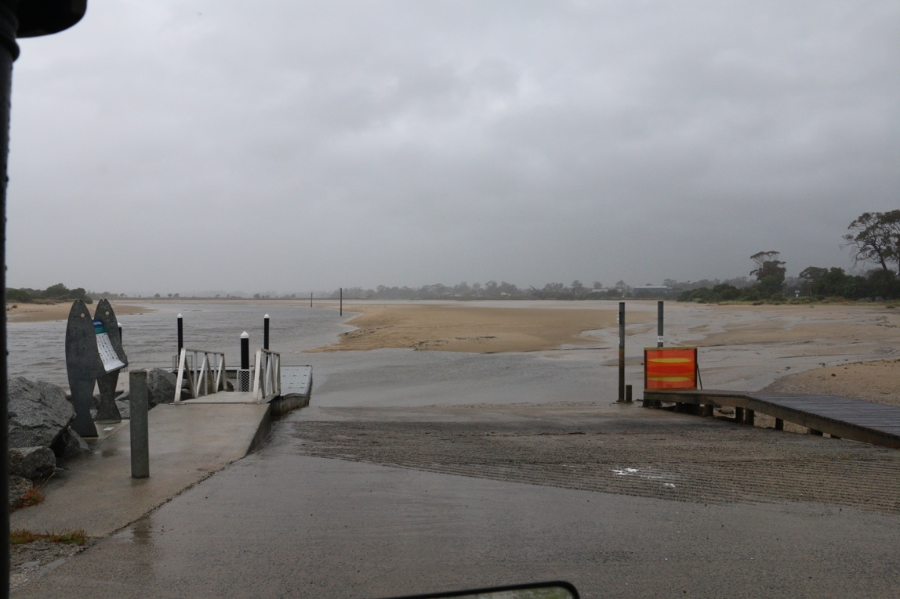
Parking Limited in small car park however parking on the nearby park/rass area is possible.

Cost Nil

Facilities Good fenders on pontoon. Nil fish cleaning facilities.

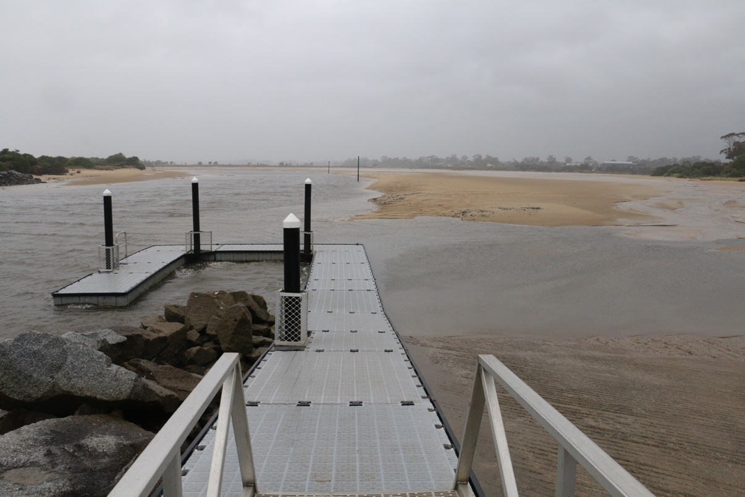

Fuel
Caltex, 71 Main St., Bridport (03) 6356 1215
Services
The main shopping strip is only 1.2 km from the boat ramp and has a small supermarket, several cafes and a hotel. The boat ramp is beside a very nice caravan park that runs along the beach from the estuary mouth almost as far as the Pier Point boat ramp to the west. This caravan park has plenty of grass, shade and good facilities. They will also let you have open fires. https://bridportcaravanpark.com.au

Fishing Tackle & Bait
There is a small amount of fishing tackle available in the local supermarket.

Local Knowledge

This ramp is in the Bridport Estuary at a place known as Trent Waters. Many locals prefer to use this ramp in the estuary over the Pier Point ramp because it is protected in all weather and can be used in all tides.

The estuary entrance is approximately 450 metres from the ramp and is vulnerable to tidal influence. It has a shifting sand bar which is impassable at low tide. Within one hour of low tide either side the bar is okay. It is not generally a dangerous bar by virtue of waves, etc. but the sandbar has caught quite a few tourists who have hit it at low tide and been stranded and people have been propelled overboard.

There is a rock to the eastern end of the entrance which is marked with a short pole.

This estuary is regularly used by commercial fisherman and the Bridport to Flinders Island ferry.

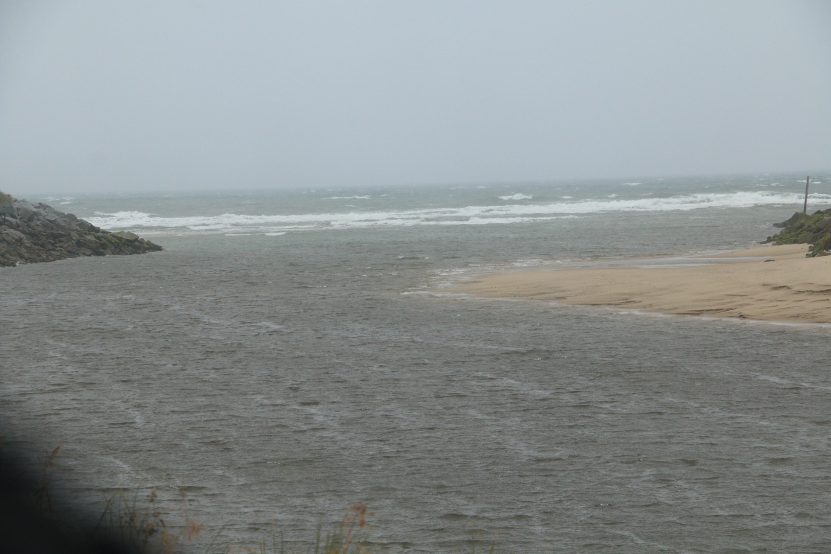

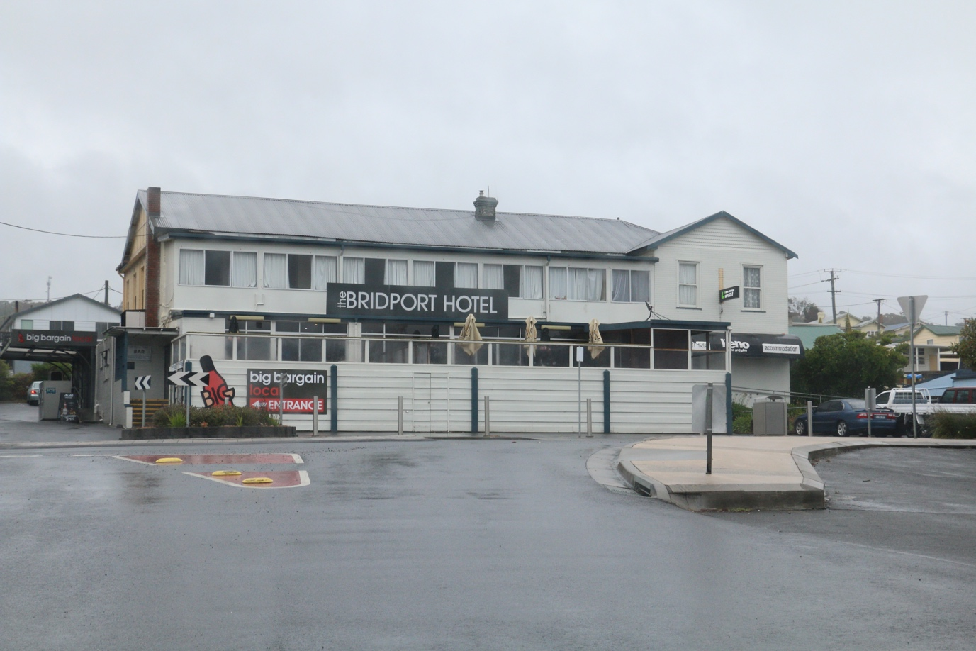

Boat Ramp Etiquette

To avoid ramp rage, please try and remember these basic boat ramp rules when launching and retrieving:-

Prepare your boat before you reverse onto the ramp – ie bungs in, straps off and equipment in the boat

Beware of slippery ramps, particularly when tide is low – if you have a four wheel drive, use it. Every year, cars are ruined when they are dragged by their boats into the water during launching or retrieval.

Make sure you have plenty of fuel and your batteries are working – running out of fuel or dead batteries are the two most common reasons for boaters needing rescue every year.

If you are going offshore and there is a facility such as Marine or Sea Rescue, Coastguard, or VMR which operates a log on and log off service, use it.

