Geraldton
Stella Marsh Dve., Geraldton, West Australia

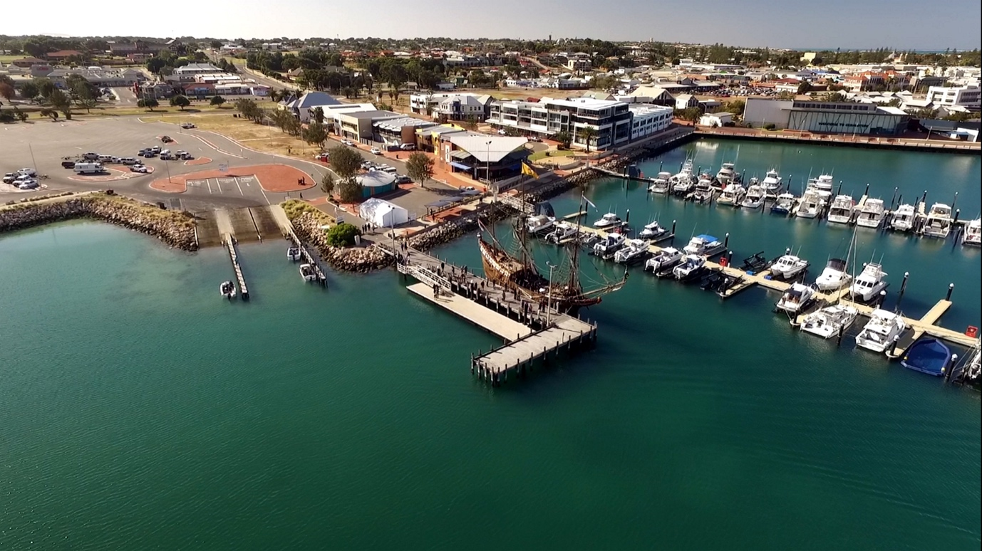

GPS 28°45'58.37"S 114°36'46.90"E

Lanes 2 Surface Concrete Condition Good
Wharves 2 Floating pontoons
Tides Works in all tides

Parking Ample

Cost Nil

Facilities ??? TBA

Fuel (Closest)
Caltex 84 Sanford St., Geraldton
BP Lot 1662 Sshenton St., Geraldton
Coles Express 115 N W Coastal Hwy., Geraldton (24 hour)
United Petroleum, 50 Rifle Range Rd., Rangeway

Services (closest)
Approx 150 metres to Northgate shopping Centre Cafes, Restaurant, Supermarket, Liquorland etc.

Fishing Tackle & Bait
BCF 175 N W Coastal Hwy., Geraldton http://www.bcf.com.au/Stores/BCF-Geraldton/376

Getaway Outdoors, 208 N W Coastal Hwy., Geraldton
https://getawayoutdoors.com.au/Fishing-Reports

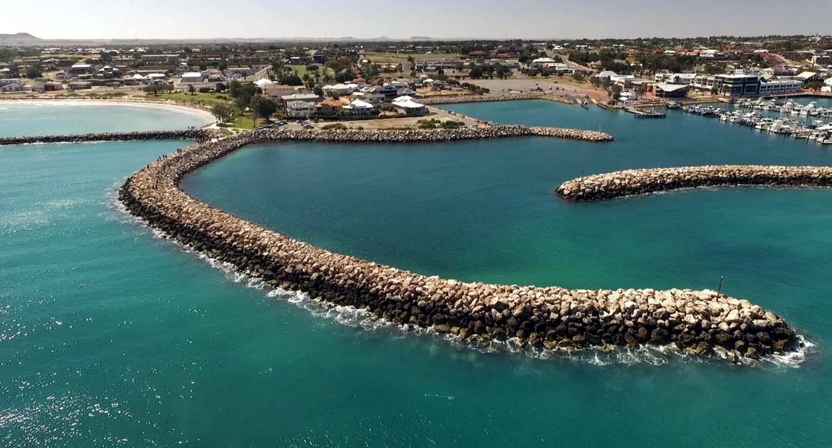

Local Knowledge

As can be seen from the aerial photo, this boat ramp is very well protected from the often quite windy conditions of the Batavia Coast.

This report is incomplete and is awaiting further information regarding local knowledge of this ramp. If you can provide further useful information please email same to admin@boatingdownunder.com.au or call Corf on 0428092472.

Boat Ramp Etiquette

To avoid ramp rage, please try and remember these basic boat ramp rules when launching and retrieving:-

Prepare your boat before you reverse onto the ramp – ie bungs in, straps off and equipment in the boat

Beware of slippery ramps, particularly when tide is low – if you have a four wheel drive, use it. Every year, cars are ruined when they are dragged by their boats into the water during launching or retrieval.

Make sure you have plenty of fuel and your batteries are working – running out of fuel or dead batteries are the two most common reasons for boaters needing rescue every year.

If you are going offshore and there is a facility such as Marine or Sea Rescue, Coastguard, or VMR which operates a log on and log off service, use it.

