Hastings Harbour
Marine Pde., Hastings, Victoria

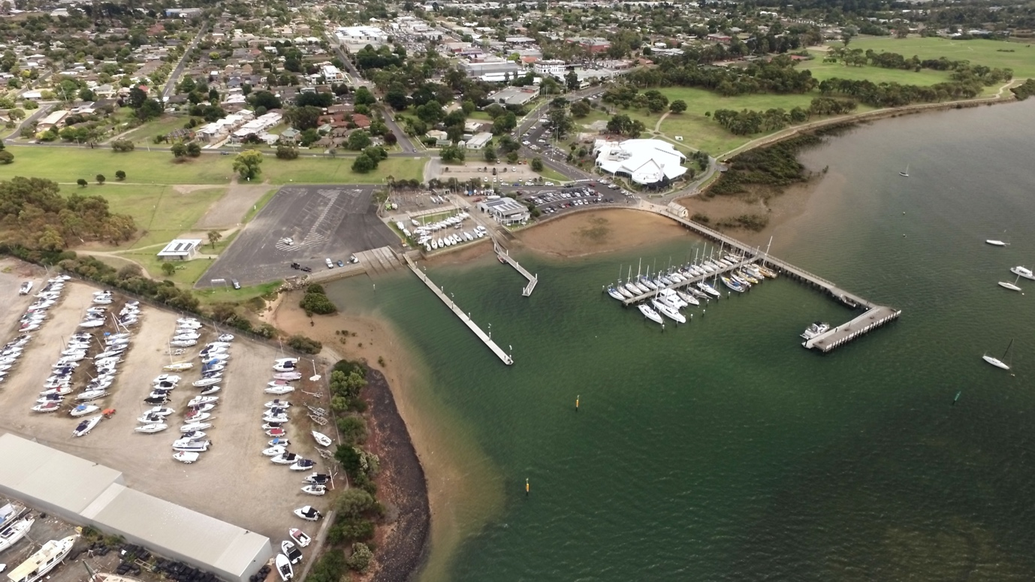

GPS 38° 18’ 35”S 145° 11’ 52”E

Lanes 4 Surface Concrete Condition Fair
Wharves 1 Floating wharf
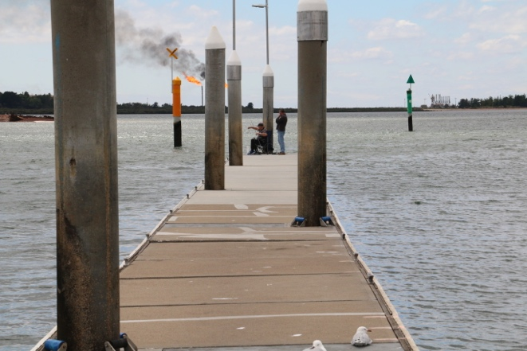
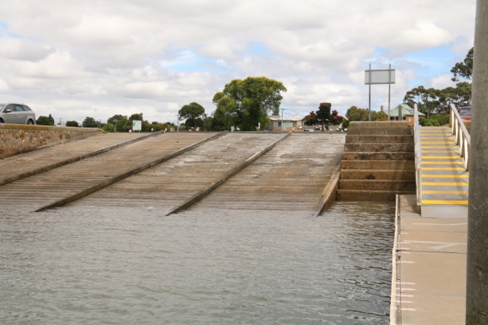
Tides Works in all tides*

Parking Ample parking. Even on the busiest day there is access to overflow parking on the paddocks surrounding the ramp car park.

Cost $11 per day. Can obtain annual ticket from the Mornington Peninsula Shire for $125. This permit allows you to use six ramps in the shire for a 12 month period from 01 November to 31 October. Day Tickets can be purchased on line.

Facilities Fish cleaning table, Fish bin, Water, Toilets, Lighting

Fuel
United , 1996 Frankston-Flinders Rd., Hastings 24 hour
United, 219 Marine Pde., Hastings
Caltex, 2098 Frankston-Flinders Rd. Hastings
Coles Express 152 High St., Hastings

Services
Approx 300 metres from the ramp is the Main St. shopping centre. Cafes, Supermarket, Hotel, Bottle Shop, etc. Restaurant in Marina complex.

Fishing tackle & Bait
Spot on Fishing Tackle, 112 Marine Pde., Hastings. Phone (03) 5979 2899
Tackleworld, 270 South Gippsland Highway
Cranbourne Phone 03 5996 6500

Fishing Club
Westernport Angling Club
Can be contacted via website at http://www.wpac.com.au/

Local Knowledge

This ramp is protected in all but the worst winds. The biggest problem with this ramp is the serious drop off at the end of the ramp. The water in Westernport is very tidal and muddy so the end of the ramp cannot be seen and on a very low tide it is quite easy to drive the trailer too far into the water and drop it off the edge of the ramp. As the hole is deep, the trailer cannot be driven out without damaging the mudguards and possibly even the trailer axle.

If this happens, instead of trying brute strength to lift the trailer wheels back onto the ramp, try using the boat anchor winch to lift the trailer back onto the concrete. You will need someone to drive the car up the ramp as the winch pulls the trailer up vertically. It takes a little bit of co-ordination but is a lot easier than physically manhandling your trailer.

In such conditions it is a good idea to place someone on the floating wharf at the fourth crack in the concrete panels and by taking a line from this position at right angles to the wharf across to a yellow pole (see photo) and then a vehicle can be safely guided back to the point where the drop off is.

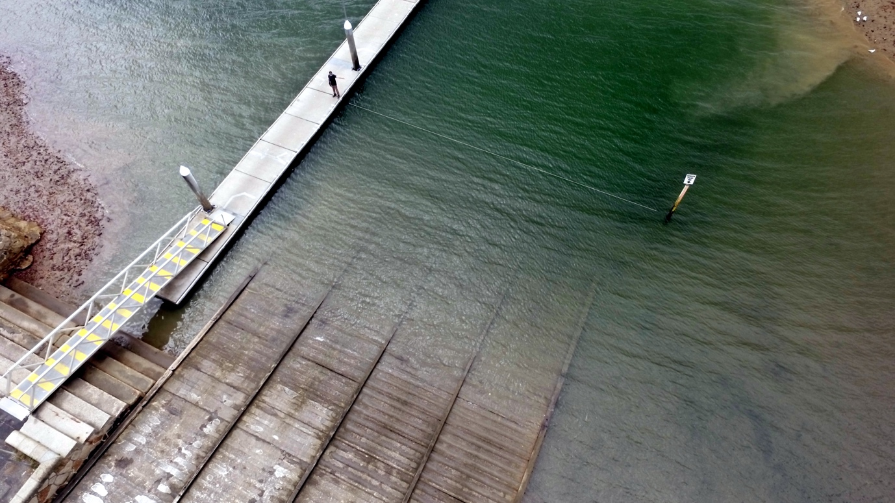

Be careful of the rams horns cleats that are fixed to the side of the floating wharf. These cleats are too close to the edge of the wharf and if your boat has a decent curve on the hull, the cleats can make contact with the hull causing some potentially nasty damage.

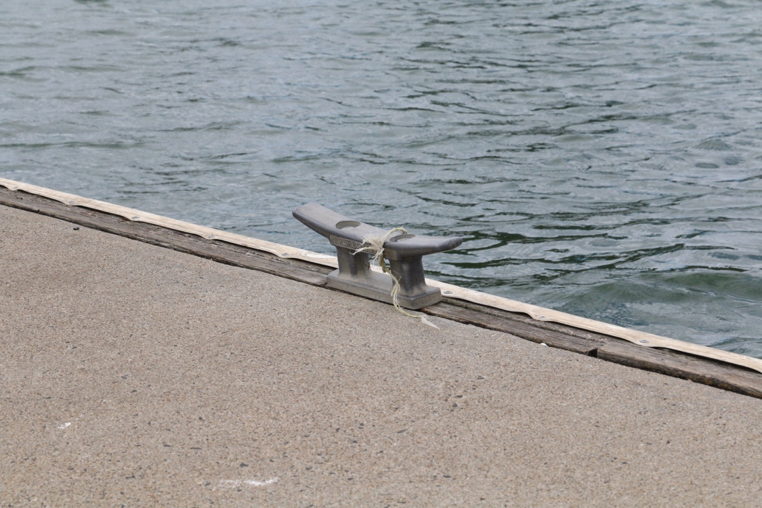
Boat Ramp Etiquette

To avoid ramp rage, please try and remember these basic boat ramp rules when launching and retrieving:-

Prepare your boat before you reverse onto the ramp – ie bungs in, straps off and equipment in the boat

Beware of slippery ramps, particularly when tide is low – if you have a four wheel drive, use it. Every year, cars are ruined when they are dragged by their boats into the water during launching or retrieval.

Make sure you have plenty of fuel and your batteries are working – running out of fuel or dead batteries are the two most common reasons for boaters needing rescue every year.

If you are going offshore and there is a facility such as Marine or Sea Rescue, Coastguard, or VMR which operates a log on and log off service, use it.

