Lakes Entrance North Arm
(Also known as the Apex ramp)
Marine Pde., Lakes Entrance, Victoria

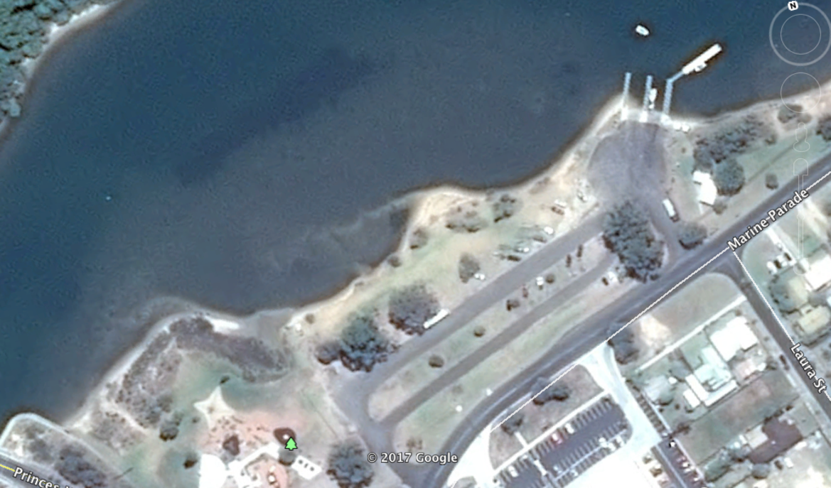

GPS 36°25'30.89"S 150° 4'23.70"E
Lanes 4 Surface Concrete with rubber matting Condition Good
Wharves 2 jetties and 1 floating pontoon
Tides Works in all tides

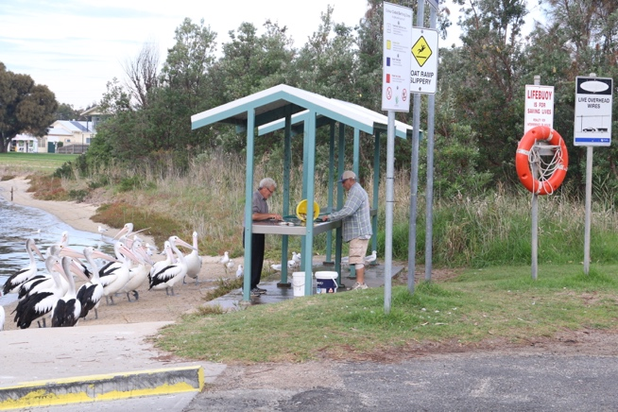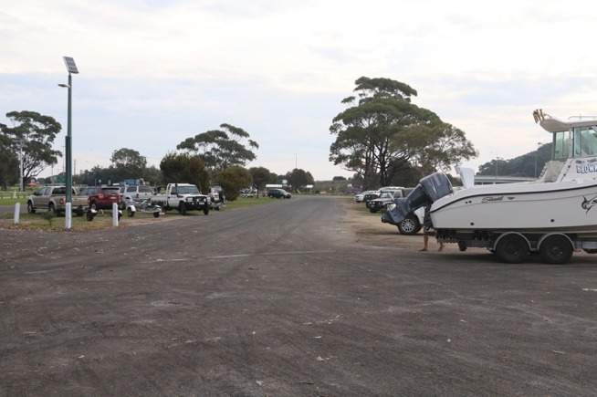

Parking Ample parking at no cost.
Cost Nil
Facilities 2 Fish cleaning tables, Bin, Lighting, Toilets with shower

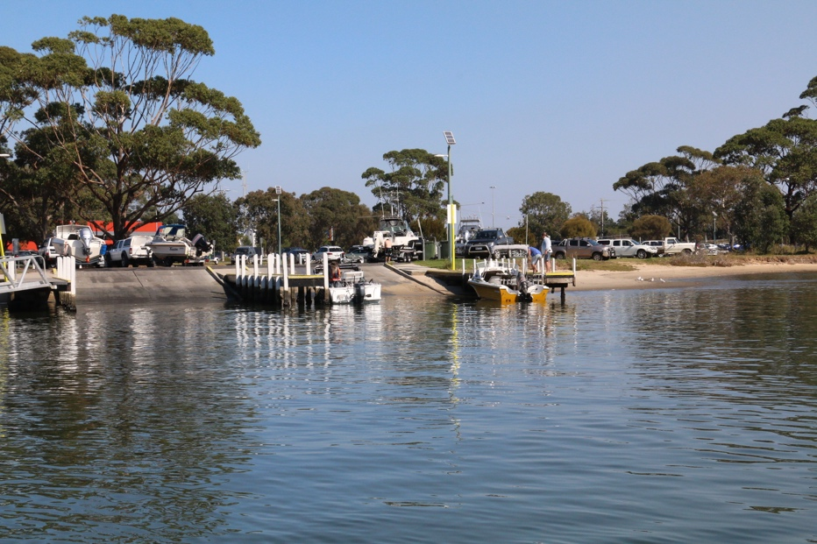

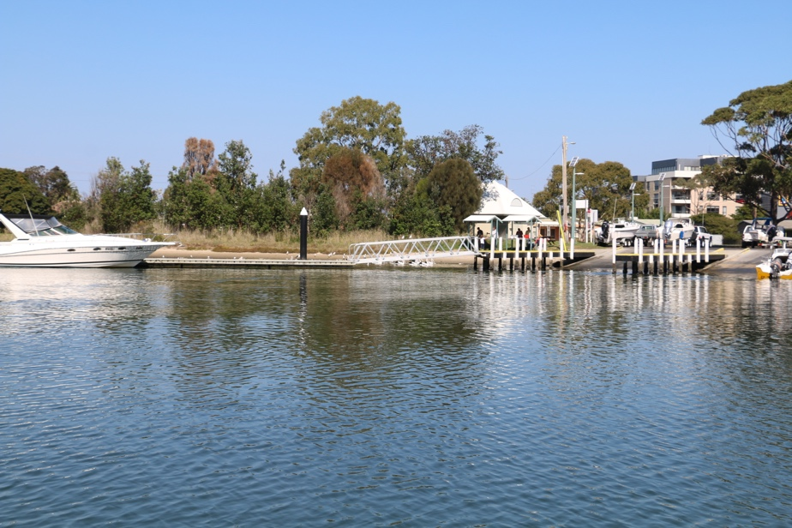

Fuel
Shell 66 Marine Pde., Lakes Entrance
Caltex 413 Esplanade, Toorloo Arm, Lakes Entrance (03) 5155 1614
Mobil 16 Princes Hwy., Lakes Entrance, (03) 5155 212

Services
300 metres from the boat ramp is the main shopping area on the Esplanade (Princes Hwy.) where you can find the Lakes Entrance Hotel, cafes, newsagent, bakery, butcher, greengrocer and a Woolworths Supermarket, etc.

Fishing Tackle & Bait
East End Bait and Tackle Supplies, 577 The Esplanade, Lakes Entrance 03 51551593
Riviera Bait Supplies, 243 The Esplanade, Lakes Entrance
51552263

Local Knowledge
This is a very sheltered boat ramp with plenty of parking and good facilities. There is plenty of berthing with three wharf arms and the floating pontoon and if things are particularly busy, there is also a sand beach beside the ramp to beach the boat on to wait.

There are actually three boat ramps within half a km of each other in this area. Two are suitable for big boats; being this one and the North Arm bridge ramp. The third is further east along the north arm and is really only suitable for dinghies and jetskis.

The ramp is in good condition which is very typical of all major ramps on the Gippsland Lakes. The jetties are all painted in varying colours which designate how long a boat can stay tied up on the jetty. Signs clearly explain what the colours mean.

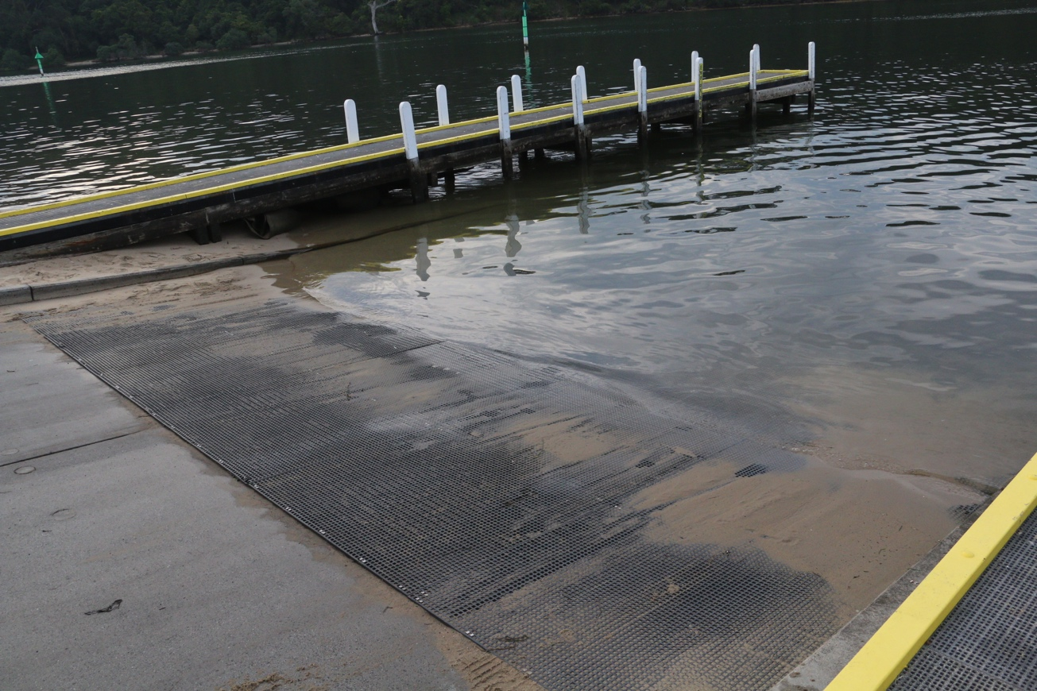

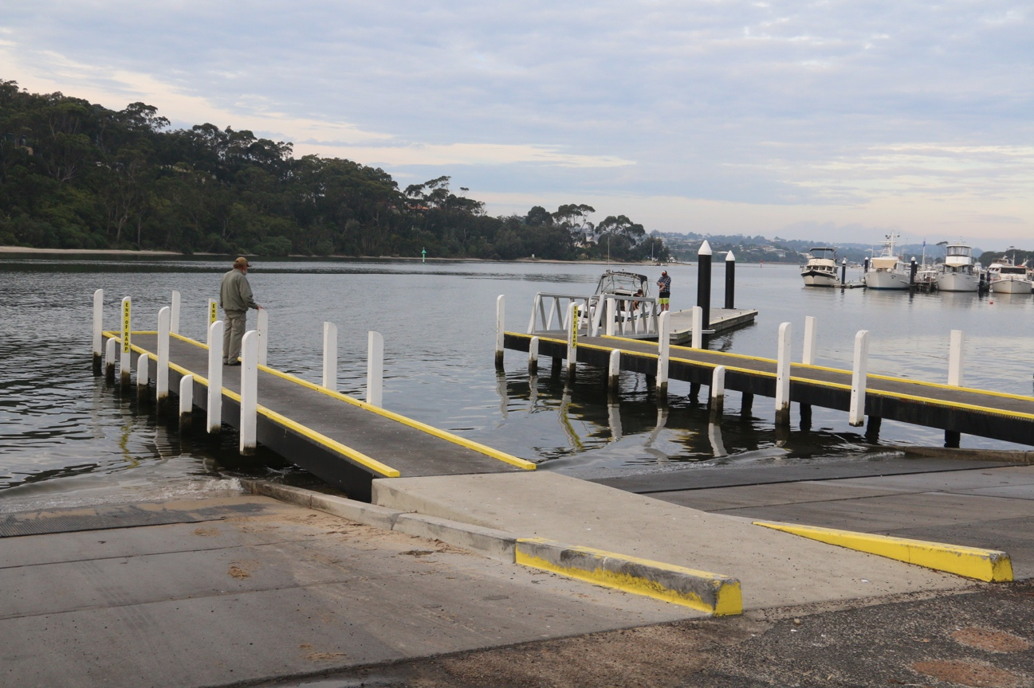
Boat Ramp Etiquette

To avoid ramp rage, please try and remember these basic boat ramp rules when launching and retrieving:-

Prepare your boat before you reverse onto the ramp – ie bungs in, straps off and equipment in the boat

Beware of slippery ramps, particularly when tide is low – if you have a four wheel drive, use it. Every year, cars are ruined when they are dragged by their boats into the water during launching or retrieval.

Make sure you have plenty of fuel and your batteries are working – running out of fuel or dead batteries are the two most common reasons for boaters needing rescue every year.

If you are going offshore and there is a facility such as Marine or Sea Rescue, Coastguard, or VMR which operates a log on and log off service, use it.

