Lemon Tree Passage
Port Stephens, NSW

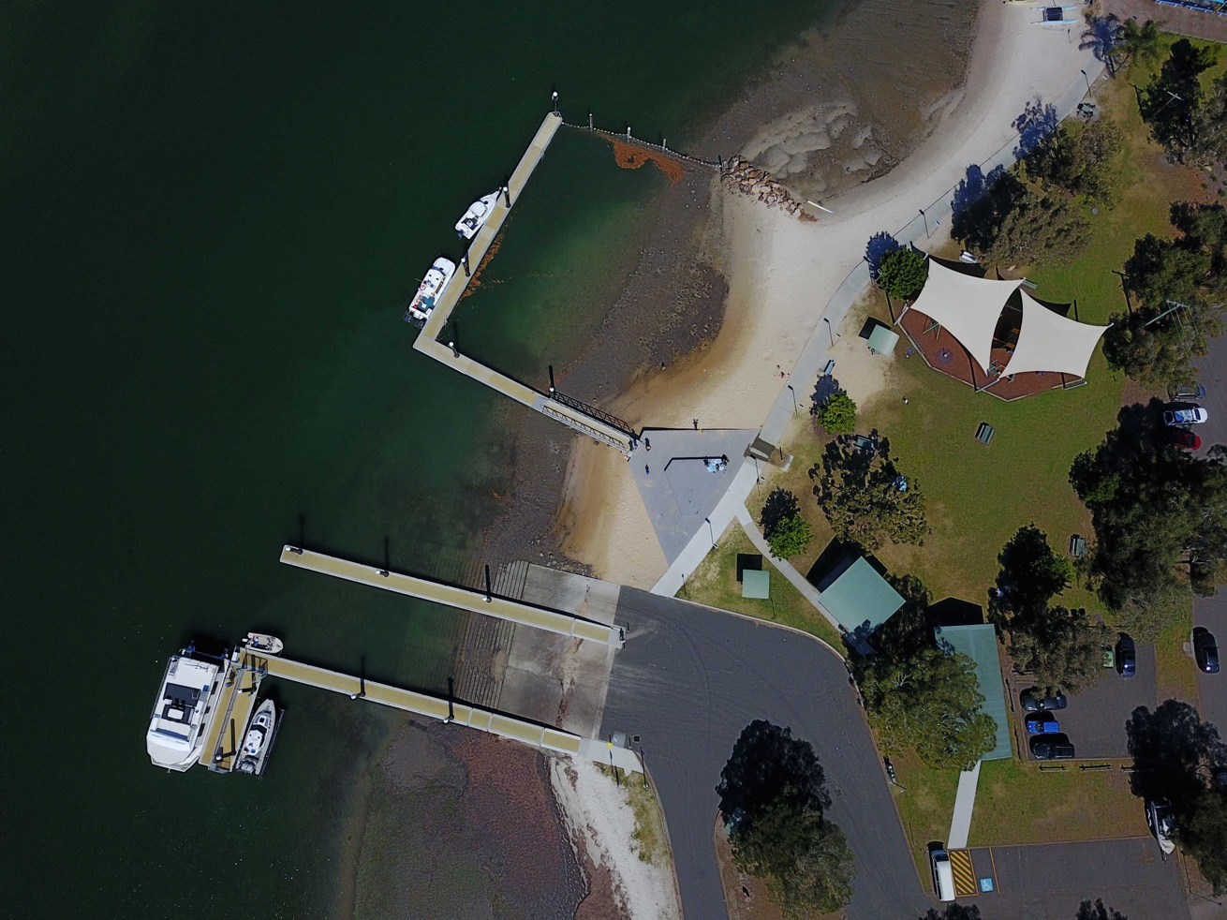

GPS 32°43'47"S 152°02'24"E

Lanes 3 Surface Concrete Condition Good
Wharves 2 floating pontoons
Tides Works in all tides

Parking Ample parking at this boat ramp. Bituminised car park.
Cost Nil

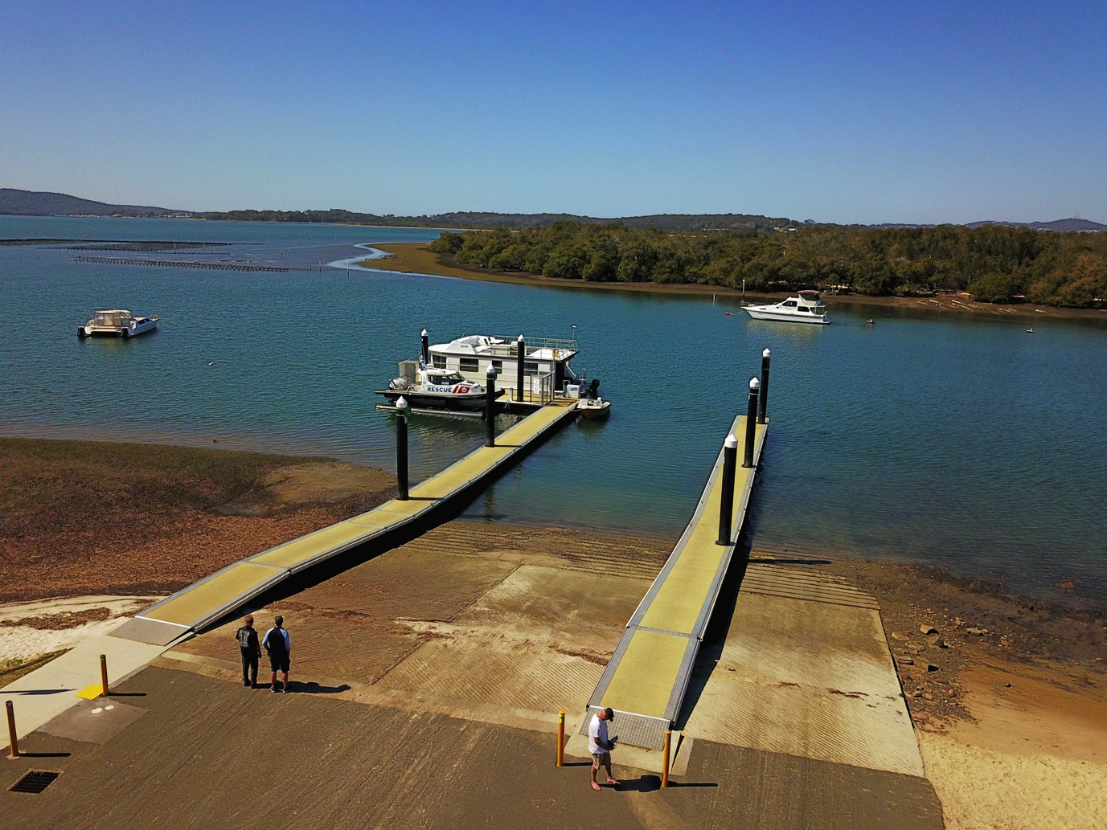

Facilities Fish cleaning table, toilets, picnic tables

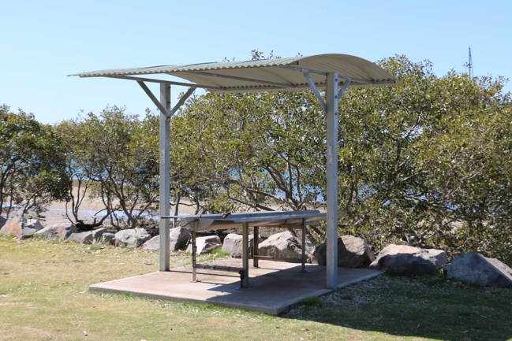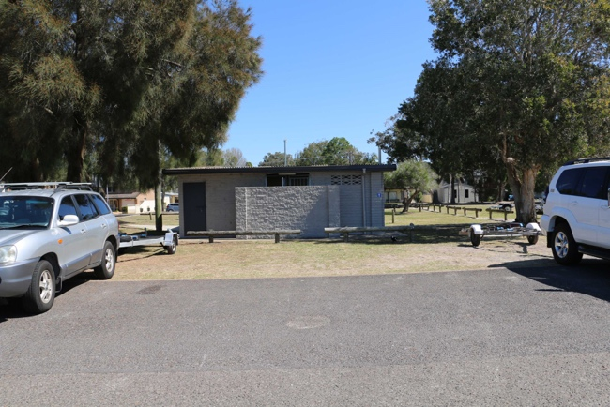

Fuel
Tanilba Bay Fuel Station, 46 President Wilson Walk, Tanilba Bay Ph: 02 49823295 or 0487704866 (Closest fuel to ramp 3.6 km from Lemon Tree Passage)
Salamander Bay Service Station, Cnr. Randall Dve. and Monkey Ave., Salamander Ph: 02 49827396
Caltex, 216 Nelson Bay Rd., Anna Bay Ph: 024190055

Services
This ramp is in the heart of Lemon Tree Passage which is a very small village consisting of a couple of take away food shops, bottle shop, pharmacy, bakery, post office, butcher and a book shop. If you want some serious provisioning, you should go to the Coles Supermarket at nearby Tanilba Bay. (approx. 4 km)

There is a marine service centre, boat hire business and chandlery on the town foreshore.

Fishing Tackle & Bait (closest to ramp)
Boating Fishing LTP.com This is an online store but also has a shop in Lemon Tree Passage at 3/44 Cook Pde., Lemon Tree Passage. Ph. 0402844223 or 02 4982 5348

Local Knowledge

This ramp was upgraded in 2016 and is in good condition. Lemon Tree Passage is a very protected waterway. It is possible to enter the passage from either the north or the south but the water is deeper approaching from the south. The NSW Maritime Transport map for the waterway is a very good map and states that the northern entrance to Lemon Tree Passage is too shallow at low tide to be used by deep draught vessels.

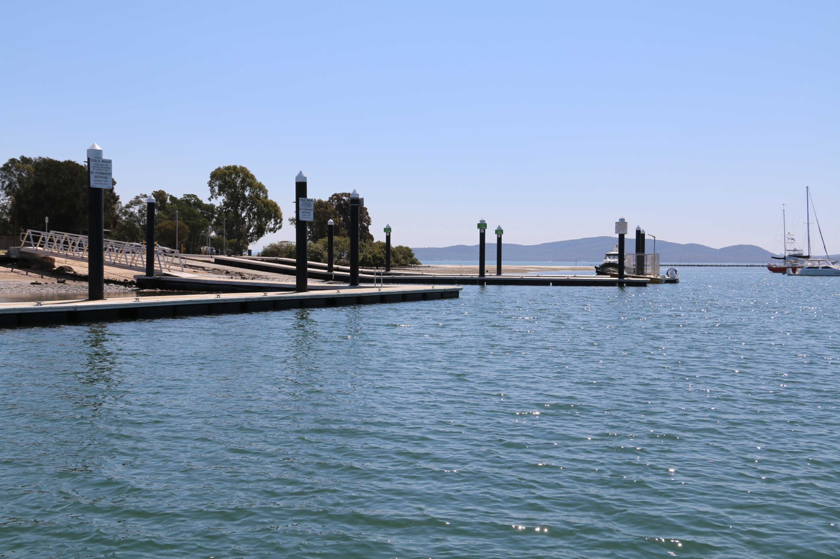

One of the best things about the ramp is the amount of berthing space present against any one of three pontoons. Additionally there is a lot of water space to the south of the ramps allowing for the movement of multiple boats at the same time.

The floating pontoons are all new and well fendered.

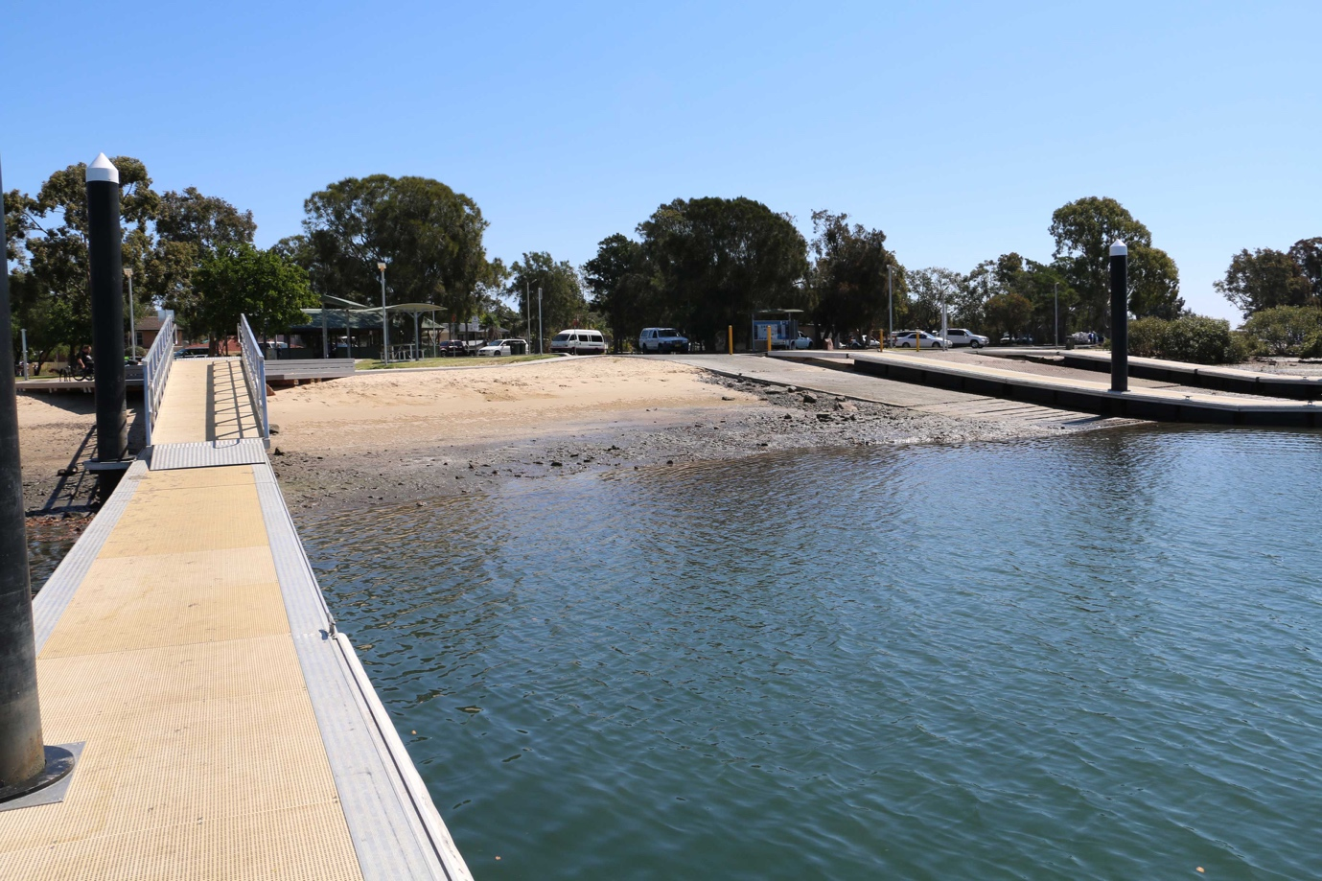

Despite the fact that this ramp is relatively new, the ramp itself can be slippery with weed possibly because the water is nearly always calm as it is a very protected waterway at Lemon Tree Passage which allows the weed to grow. More than one car has slid into the water whilst launching a boat at this ramp since its upgrade.

If you want to go boating in the open ocean, this ramp would be the furtherest away from the ocean in this area, being 18 km from the Port Stephens entrance. Refer to Boat Ramp Reports for Soldiers Point, Shoal Bay and Little Beach..

Boat Ramp Etiquette

To avoid ramp rage, please try and remember these basic boat ramp rules when launching and retrieving;

Prepare your boat before you reverse onto the ramp – ie bungs in, straps off and equipment in the boat

Beware of slippery ramps, particularly when tide is low – if you have a four wheel drive, use it. Every yearmcars are ruined when they are dragged by their boats into the water during launching or retrieval.

Make sure you have plenty of fuel and your batteries are working – running out of fuel or dead batteries are the two most common reasons for boaters needing rescue every year.

If you are going offshore and there is a facility such as Marine or Sea Rescue, Coastguard, or VMR which operates a log on and log off service, use it.

