Fishermans Beach, Mornington
The Esplanade, Mornington, Victoria

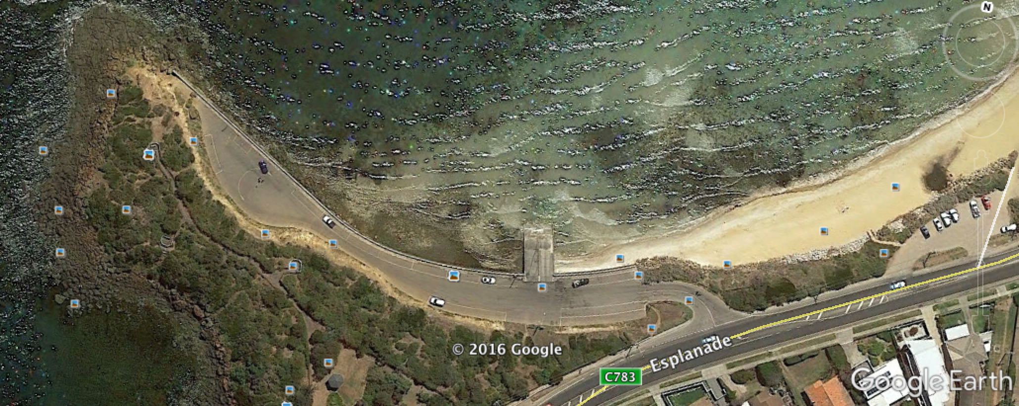

GPS 38°13'37.05"S 145° 1'38.94"E

Lanes 2 Surface Concrete Condition Good
Wharves 2 Fixed wharves, well fendered
Tides Very tidally affected. Only works from half tide to full tide and back to half low tide.

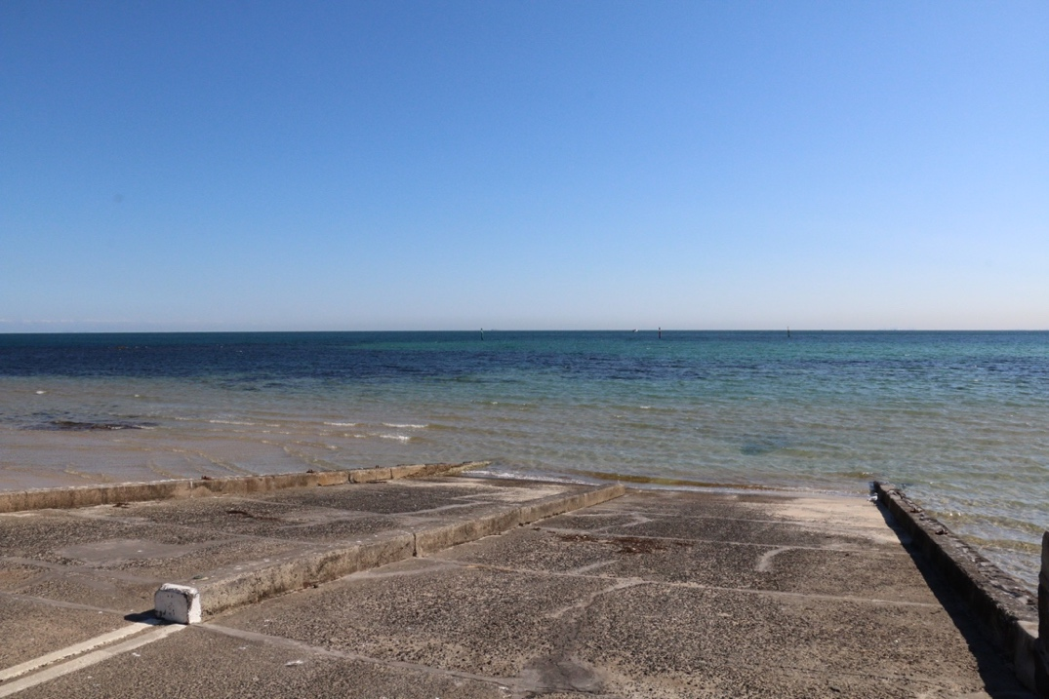
Parking Parking is limited in the ramp area, especially during the peak of the summer holidays. Parking on the Esplanade is possible.

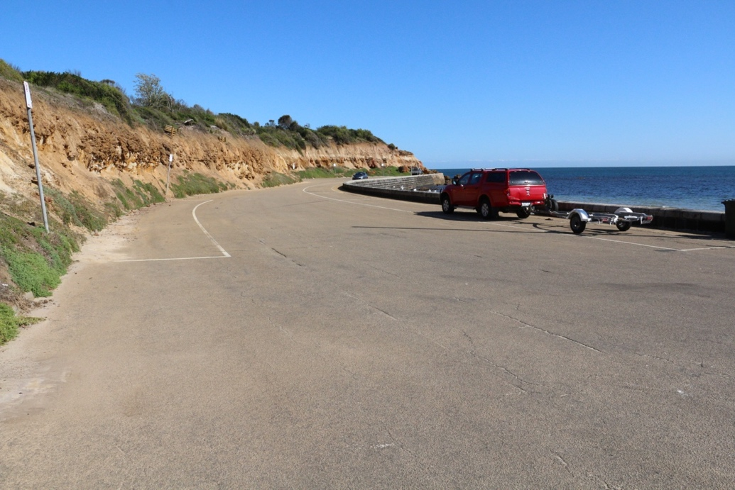

Cost $11 per day. Can obtain annual ticket from the Mornington Peninsula Shire for $125. This permit allows you to use six ramps in the shire for a 12 month period from 01 November to 31 October. Day Tickets can be purchased on line.

Facilities Toilets nearby, nil other facilities.

Fuel
Caltex 321 Main St., Mornington
Coles Express 1010 Nepean Hwy. Mornington
United Petroleum, Tyabb Rd., Mornington
Caltex Star Mart Cnr. Wilsons Rd. and Nepean Hwy. Mornington 24 hours

Services
Approx 800 metres, Main St. shopping centre. Cafes, Restaurant, Supermarket, etc.

Fishing Tackle & Bait
Tackleworld, 177 Mornington-Tyabb Rd., Mornington
http://www.tackleworld.com.au/vic/mornington.html
Sport Phillip Marine, 129 Mornington-Tyabb Rd., Mornington
http://www.sportphillip.com.au/

Local Knowledge

This ramp is not in good condition. It has gradually silted up with sand and is presently (April, 2017), only usable from half incoming tide to full tide and back down to half out. As the following picture shows this ramp is very shallow and the channel leading out from it likewise.

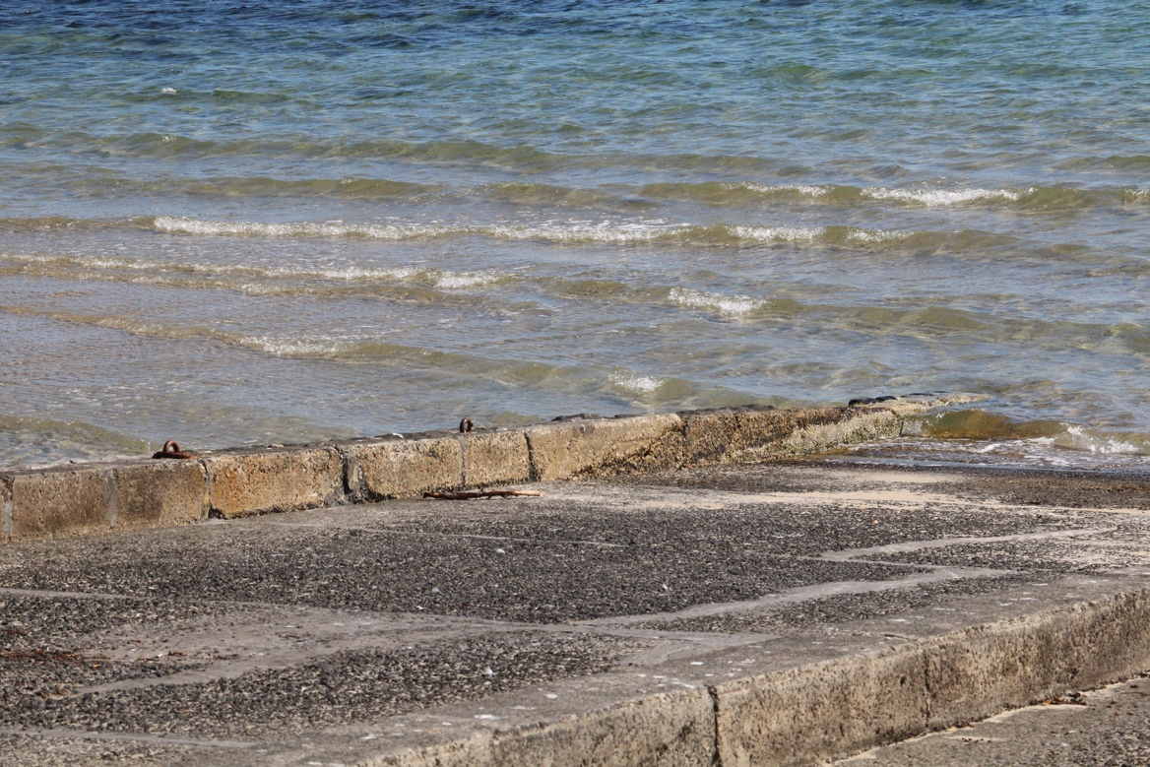

Many locals prefer this ramp because it is much less busy than the main ramp at Mornington Harbour, however locals know where the channel is and what tide to launch and retrieve in.

This ramp is not suitable for 7 metre plus boats or heavy fibreglass boats.

During Snapper Season, (Oct to late Nov) this ramp is particularly busy during the early to mid morning and parking can be difficult to obtain at the ramp.

Boat Ramp Etiquette

To avoid ramp rage, please try and remember these basic boat ramp rules when launching and retrieving:-

Prepare your boat before you reverse onto the ramp – ie bungs in, straps off and equipment in the boat

Beware of slippery ramps, particularly when tide is low – if you have a four wheel drive, use it. Every year, cars are ruined when they are dragged by their boats into the water during launching or retrieval.

Make sure you have plenty of fuel and your batteries are working – running out of fuel or dead batteries are the two most common reasons for boaters needing rescue every year.

If you are going offshore and there is a facility such as Marine or Sea Rescue, Coastguard, or VMR which operates a log on and log off service, use it.

