Tathra – Kianinny Bay
Kianinny St., Tathra, N.S.W.

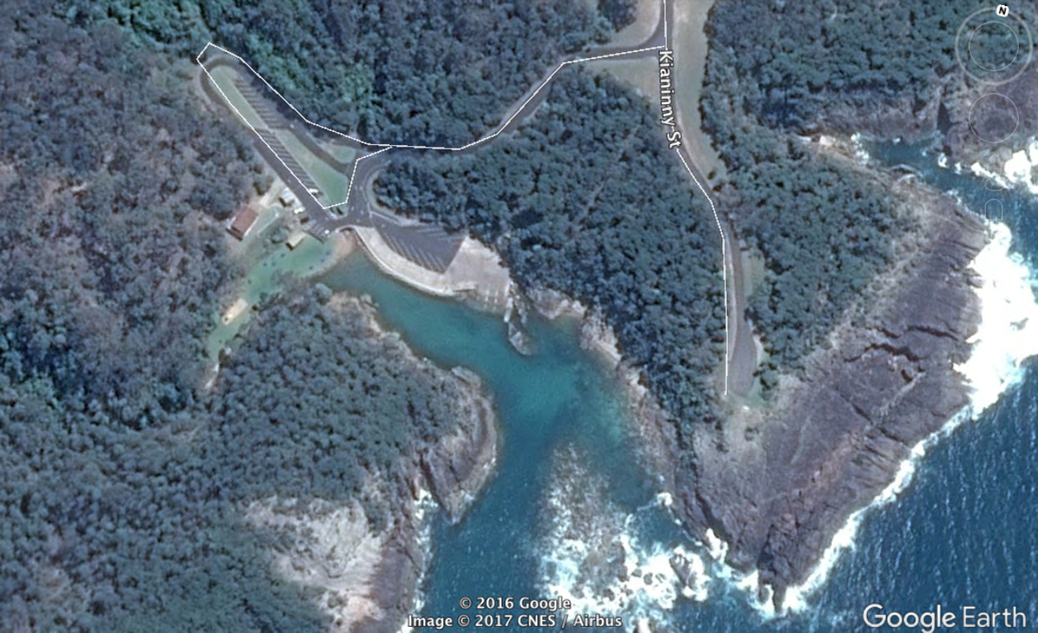

GPS 36°44'12.76"S 149°58'58.50"E

Lanes 3 Surface Concrete Condition Good
Wharves 1 Fixed wharf, well fendered
Tides Works in all tides

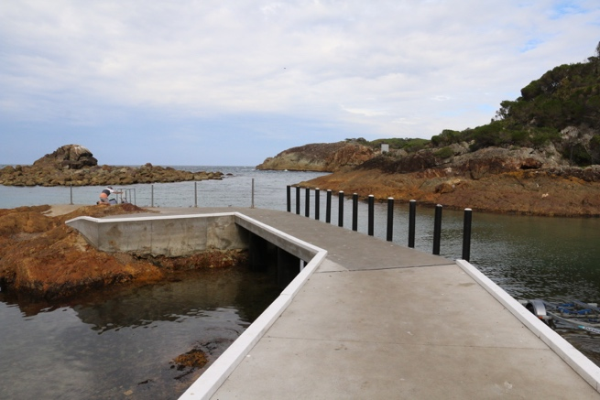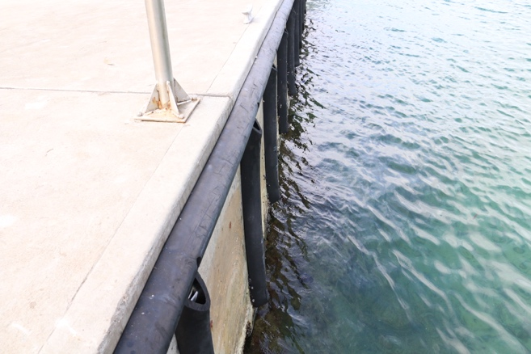
Parking Ample – Two separate areas to park cars and trailers. Both are close to the ramp.
Cost Nil despite a sign indicating payment is necessary, there is no-one to collect it.

Facilities One of the largest fish cleaning tables you will see complete with water and Fish bin, Toilets, BBQ, Picnic ground and Lighting.

Fuel
Tathra Tyres and Auto - 88 Bega St, Tathra NSW (opens at 6 a.m. and staff very helpful)
Bendy Kates Roadhouse - 2A Francis Hollis Dr, Tathra (opens at 6.30 a.m., closed on Mondays except during school holidays)

Services
Tathra is a small town with several caravan parks and a couple of little restaurants. As of April 2017, the hotel was closed and being renovated, It is expected to open in September, 2017. There is a take away bottle shop and a small supermarket.

There is a great little café/restaurant called Tathra Beach Cafe which is located on the beach next to the Life Saving Club at 8 Andy Poole Dve. It has an awesome view of the beach and is the perfect place for a brekkie or afternoon cool drink.

There is also a café at the old Tathra wharf which is the last of the old steamer wharfs on the NSW coast and worth visiting.

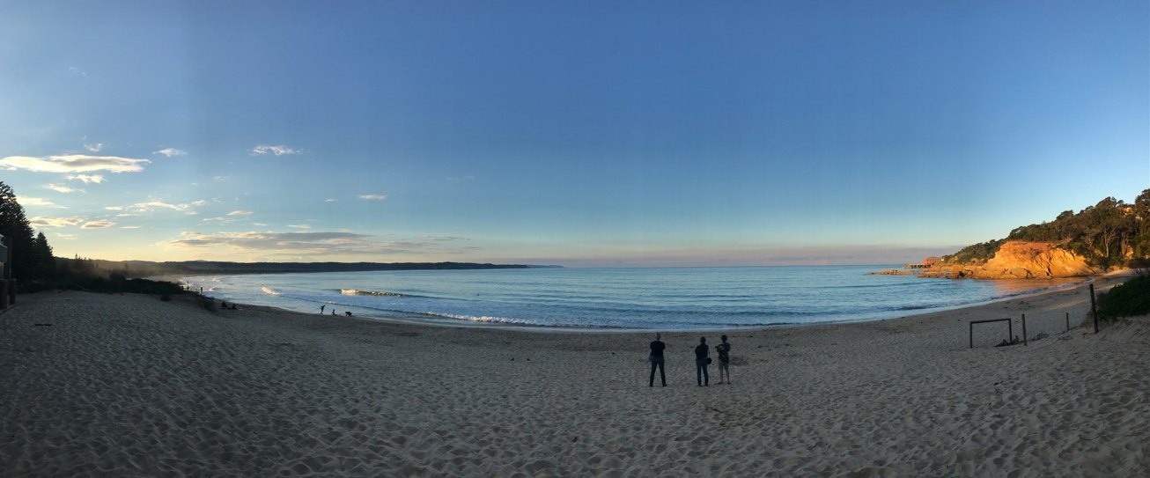

Fishing Tackle & Bait

The Tackle Box 29 Andy Poole Dve., Tathra (02) 6494 4105
Bendy Kates Roadhouse, 2A Francis Hollis Dr, Tathra
Tackleworld Merimbula 47 Market Street, Merimbula

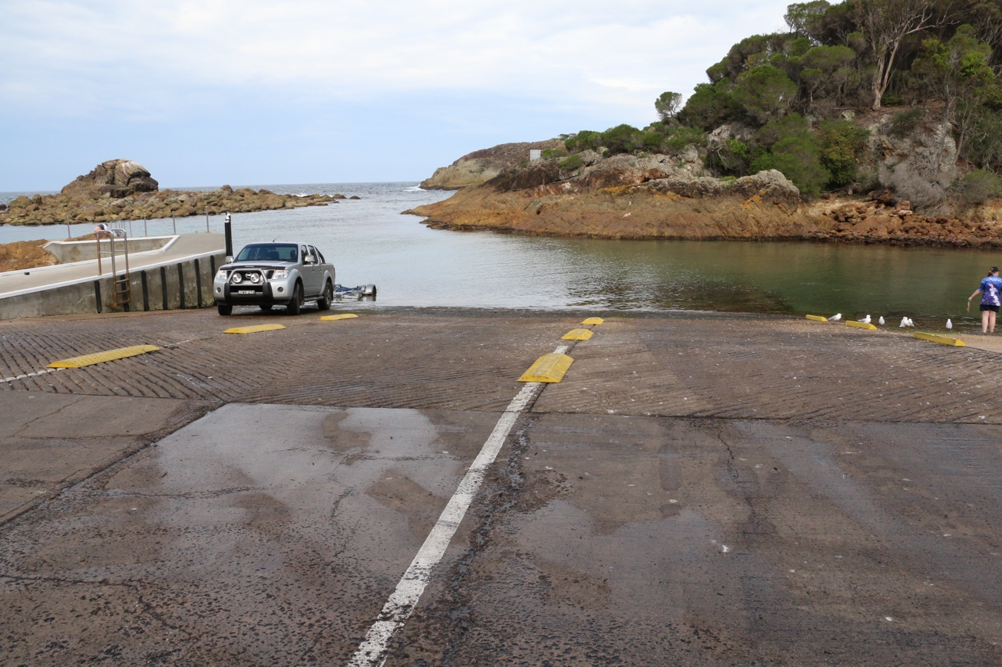

Local Knowledge

As can be seen from the photo, this is a well protected ramp unless there is some easterly in the wind which would push swell into the little harbour. The entrance is deep but relatively narrow which can be an issue in strong wind or large swell. There are good leading marks on the ocean side which if aligned will keep you I the good water. There is no bar in reasonable conditions.

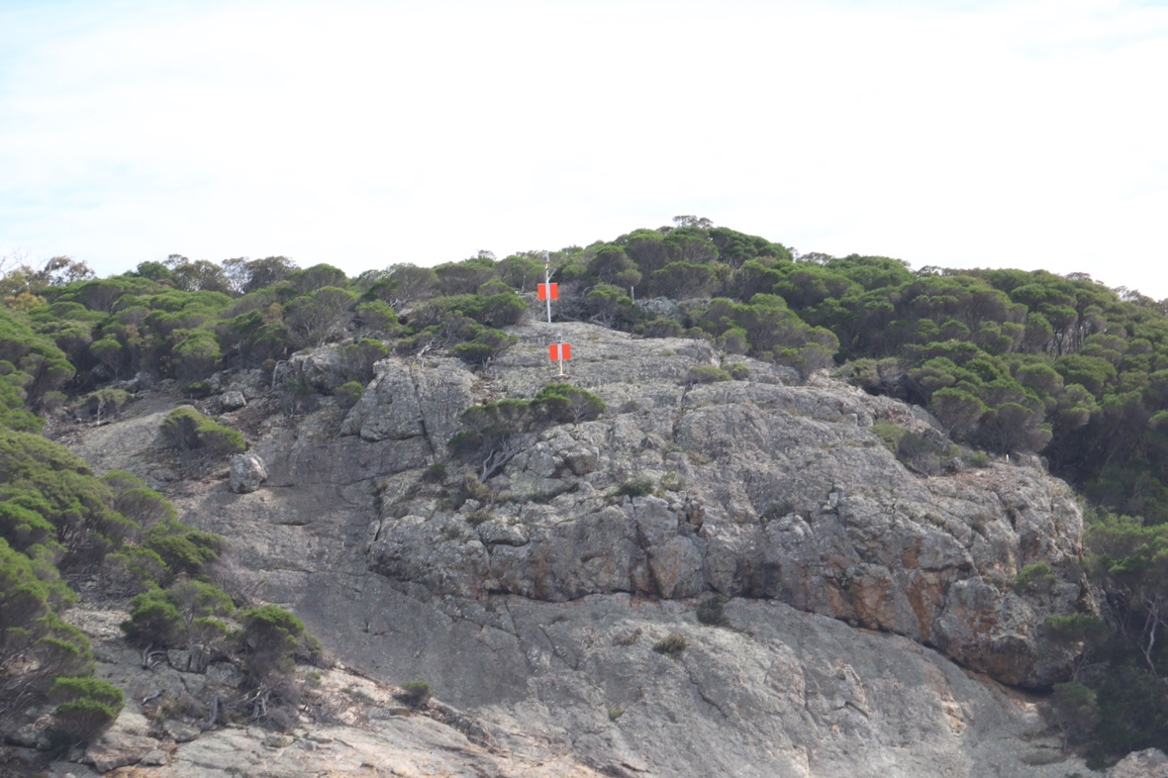

This is a pretty little inlet with a great picnic area with BBQ’S and It is popular with tourists on a sunny day. This is not a problem for parking, however people do swim in the crystal clear water and can be a problem around the ramp area.

Boat Ramp Etiquette

To avoid ramp rage, please try and remember these basic boat ramp rules when launching and retrieving:-

Prepare your boat before you reverse onto the ramp – ie bungs in, straps off and equipment in the boat

Beware of slippery ramps, particularly when tide is low – if you have a four wheel drive, use it. Every year, cars are ruined when they are dragged by their boats into the water during launching or retrieval.

Make sure you have plenty of fuel and your batteries are working – running out of fuel or dead batteries are the two most common reasons for boaters needing rescue every year.

If you are going offshore and there is a facility such as Marine or Sea Rescue, Coastguard, or VMR which operates a log on and log off service, use it.

