Warneet
Rutherford Rd., Warneet, Victoria

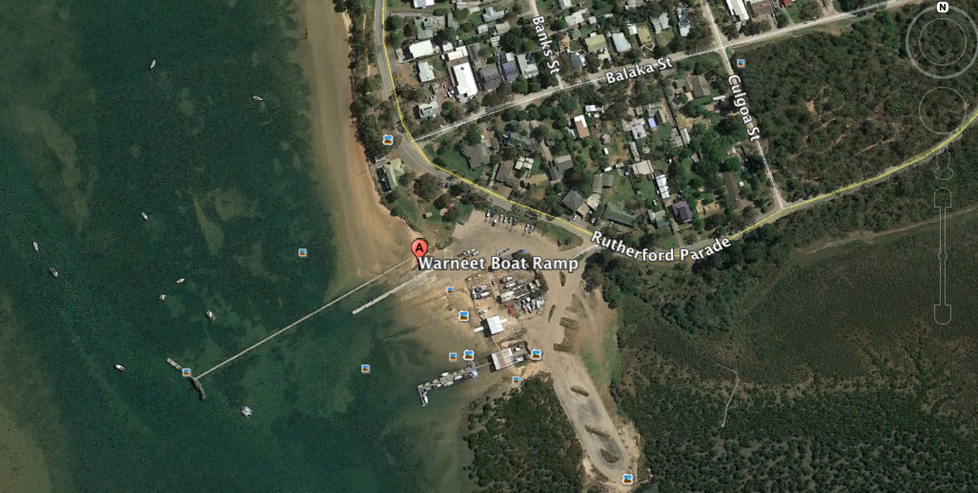

GPS 38°13'37.98"S 145°18'25.45"E

Lanes 3 Surface Concrete Condition Good
Wharves 1 floating pontoon, well fendered
Tides Unusable 2 hours before and 2 hours after low tide.

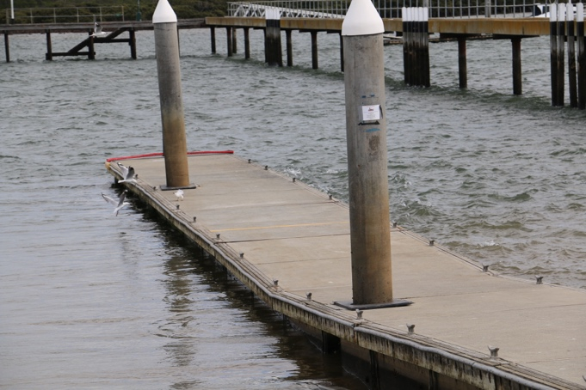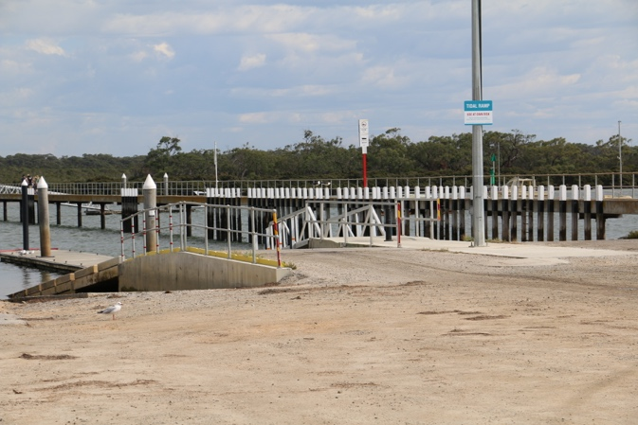

Parking The car park is gravel (soon to be bituminised) and capable of holding 160 cars and trailers. (April, 2017)

At the peak of summer it does get busy, particularly if boats have to wait for the tide to come in to get in or out. Nearby Blind Bight boat ramp is generally quieter although this too is tidal and very shallow.

Cost $12 per day. Can obtain annual ticket for $100. This covers the period from 1 Sep to June 30. Between July and September the shop is closed and parking/use of the ramp is free.

Facilities Fish bin, Water, Toilets, BBQ, Lighting A fish cleaning area is currently under construction. (April 2017)

Fuel
BP 75/99 Baxter-Tooradin Rd, Pearcedale VIC 3912
United 80-88 Sth Gippsland Hwy, Tooradin VIC 3980

Services
The ramp is owned by a foreshore committee and managed by Al Sandford who also runs a bait, tackle (very well stocked considering the limited size) and food shop next to the ramp. Al’s advice is invaluable and he is one of the most helpful people you could come across. If you are worried about the tide conditions for a launch, ring Al and he will tell you when to go to the ramp.

There is also a café next to the ramp which also sells bait and hires little fishing boats.

Fishing Tackle & Bait

Bait and tackle can be obtained from ‘Als Bait & Tackle’ shop at the ramp.

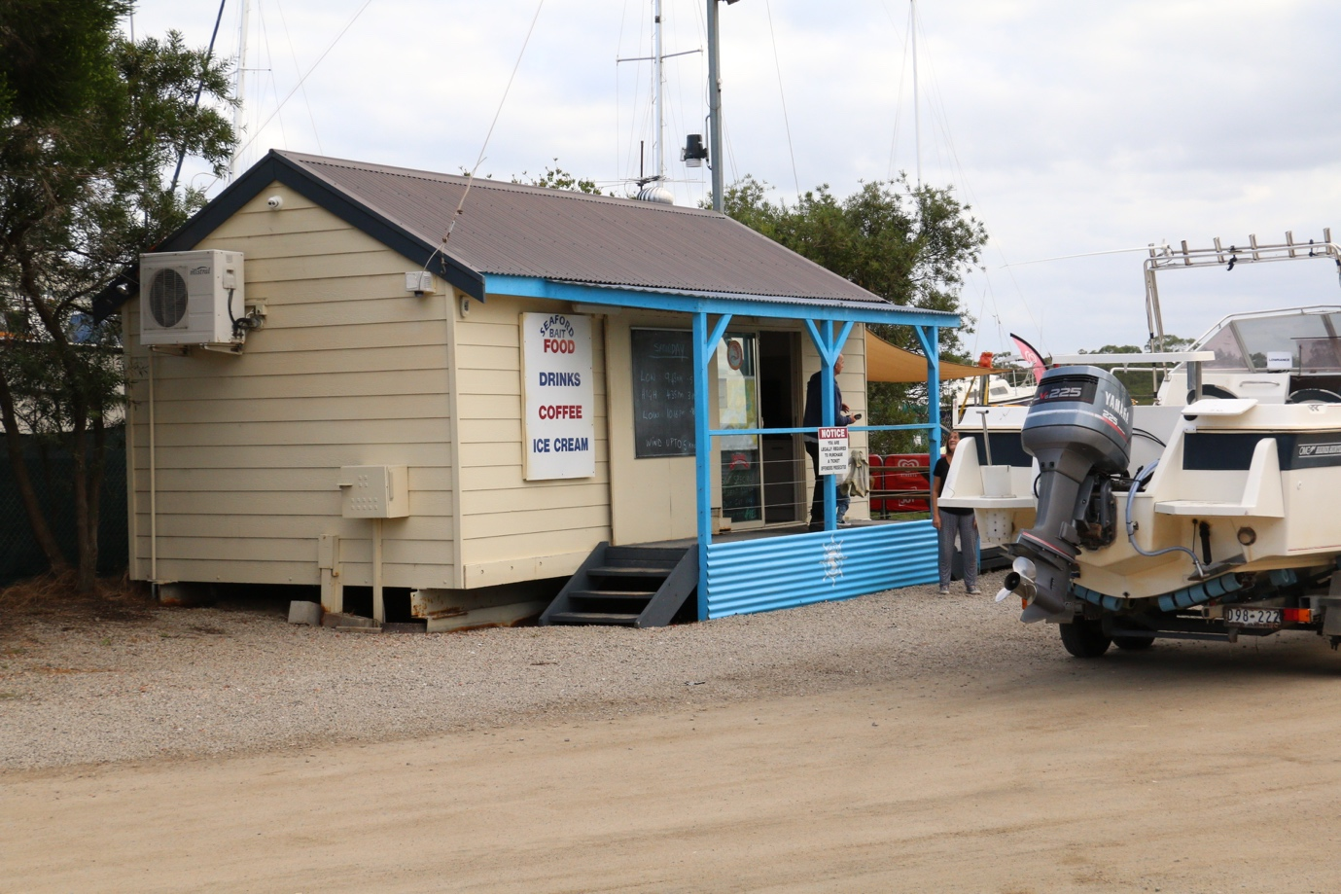
Al’s Bait & Tackle

Cranbourne Tackleworld on the Hwy is a en route if coming to the ramp from the north.

Local Knowledge

This ramp is tidal and can only be used up to two hours before low tide or 2 hours after low tide.

The ramp itself is about 3.5 km from the Westernport Bay entrance accessible via a straight channel which is designated by poles but no lights. This is the shortest distance of the three ramps on the northern end of the bay. It is well protected from the wind from all directions.

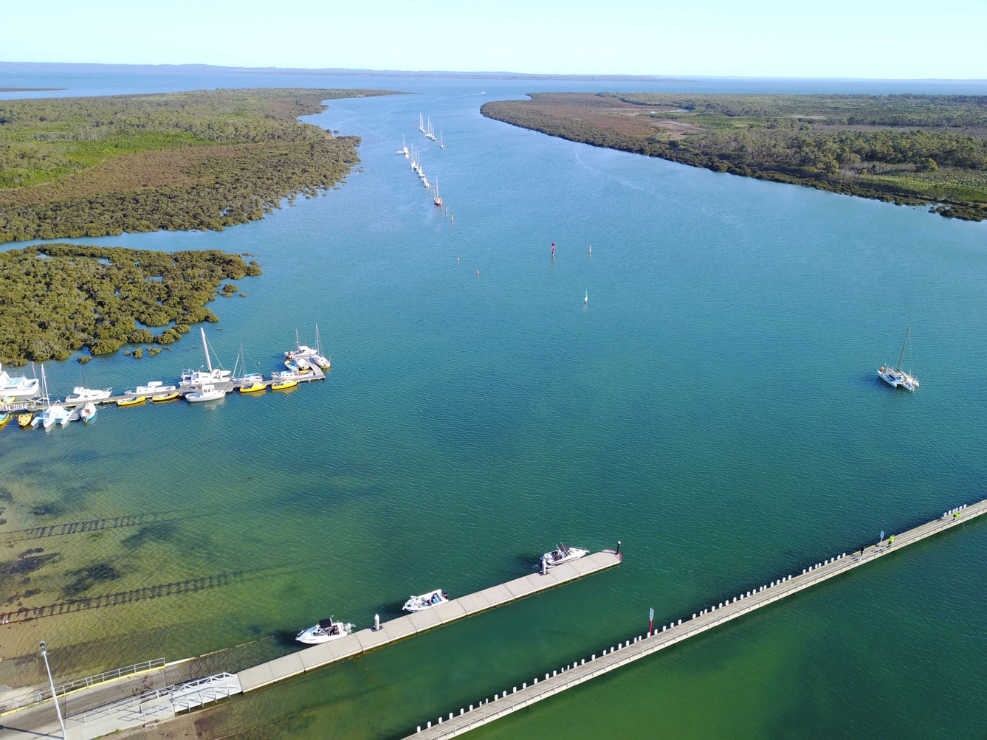
It is almost a straight run to the northern end of Westernport Bay
The ramp has three lanes, the third of which is only suitable for launching dinghies and kayaks. This ramp is on the eastern side of the ramps and has a concrete and sand base.

The two main ramps consist of corrugated concrete and are separated by a floating pontoon which is well fendered with plastic fenders.

The tide here is reasonably strong and as a result of that and of people driving boats onto trailers, there used to be a hole at the end of the two ramps which caught trailer wheels if you backed too far. This was repaired in December 2017.

There is also a nice park with tables, chairs and a BBQ next to the car park.

The best advice for anyone intending to use this ramp, is to speak to Al Sandford at Al’s Bait and Tackle and he will give you all the advice needed, including where to catch fish. You will need to call at the shop anyway to pay the parking fee.

Because the ramp is tidal, if you have to get off the bay in a hurry during the low tide period there is a jetty nearby at Warneet which is suitable for boats at all tides, so if you come in at the wrong time, you will be able to tie up to the jetty and wait unless everyone else has the same idea.

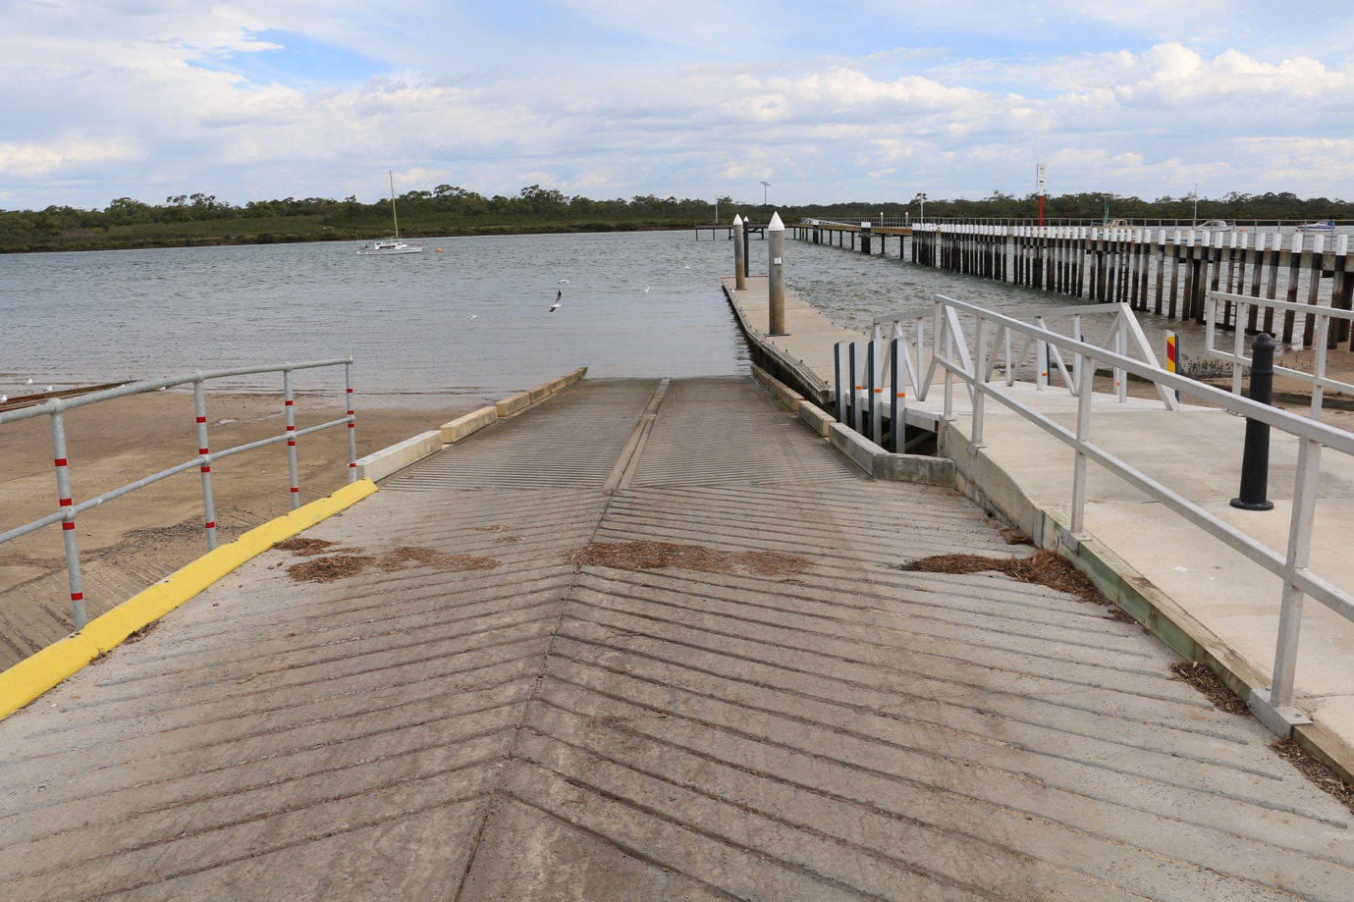

This is the best of the northern Westernport boat ramps and plans are in place to upgrade the ramp so that there will be 24 hour all tide access within the next twelve months. Pending finance and relevant approvals, this may be in place for the 2018 summer season.
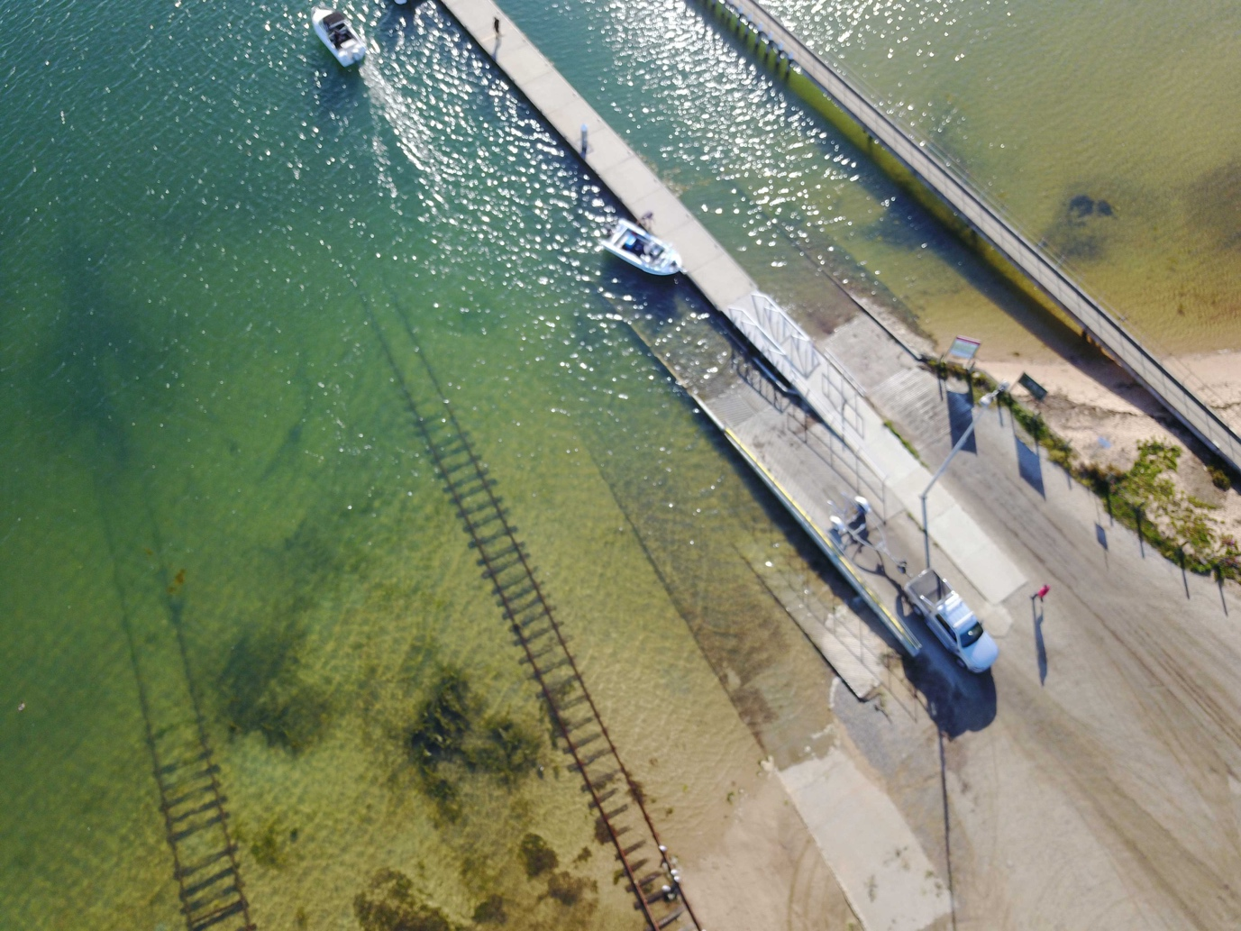
Overview of ramp showing old slipway tracks beside it

Boat Ramp Etiquette

To avoid ramp rage, please try and remember these basic boat ramp rules when launching and retrieving:-

Prepare your boat before you reverse onto the ramp – ie bungs in, straps off and equipment in the boat

Beware of slippery ramps, particularly when tide is low – if you have a four wheel drive, use it. Every year, cars are ruined when they are dragged by their boats into the water during launching or retrieval.

Make sure you have plenty of fuel and your batteries are working – running out of fuel or dead batteries are the two most common reasons for boaters needing rescue every year.

If you are going offshore and there is a facility such as Marine or Sea Rescue, Coastguard, or VMR which operates a log on and log off service, use it.

